NATIONAL INTEGRITY FORUM (NIF)

REPORT OF THE ONE-DAY NATIONAL DIALOGUE
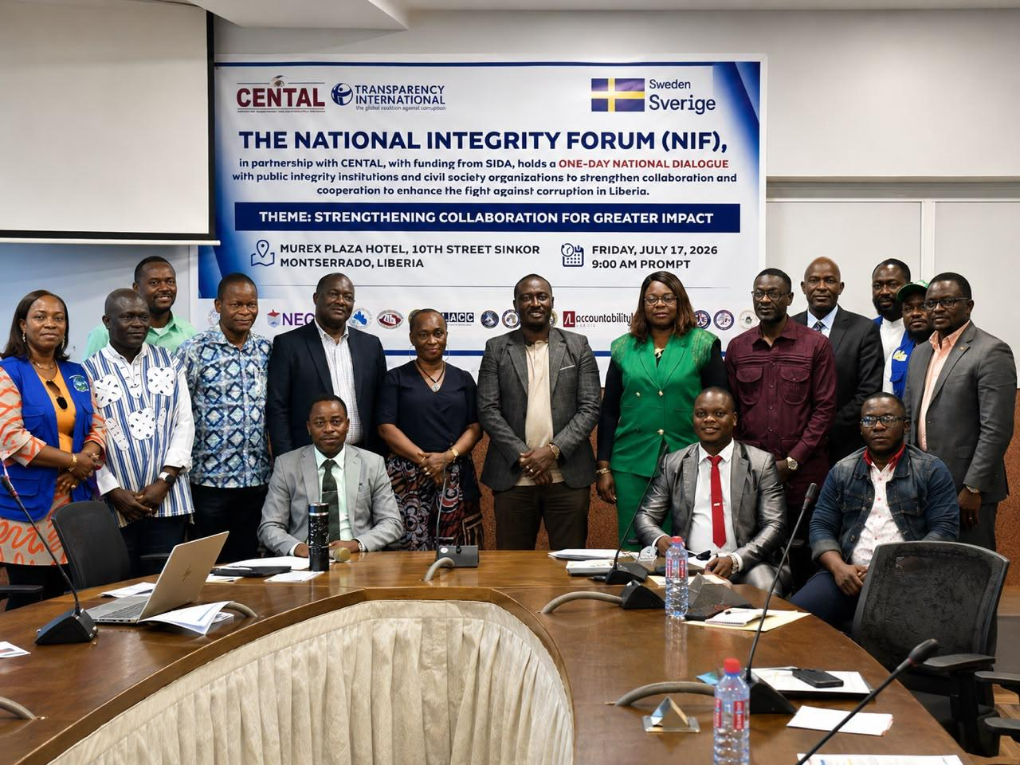

Theme:
Strengthening Collaboration for Greater Impact
Date: Friday, July 17, 2026
Venue: Murex Plaza Hotel, Sinkor, Monrovia, Liberia
Organized by:
National Integrity Forum (NIF)
In Partnership with:
Center for Transparency and Accountability in Liberia (CENTAL)

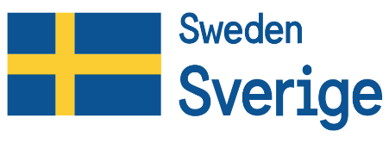
Supported by:

Executive Summary
The National Integrity Forum (NIF), in partnership with the Center for Transparency and Accountability in Liberia (CENTAL) and with financial support from the Swedish International Development Cooperation Agency (SIDA), convened a One-Day National Dialogue on 17 July 2026 under the theme, "Strengthening Collaboration for Greater Impact."
The dialogue brought together heads and senior representatives of Liberia's public integrity institutions, civil society organizations, and development partners to reflect on the National Integrity Forum's progress over the past sixteen years and to identify strategic priorities for strengthening its institutional effectiveness and long-term sustainability.
Discussions focused on key areas essential to the Forum's future, including the development of a Standard Policy Document (SPD) and supporting governance instruments, strengthening institutional collaboration, promoting sustainability beyond donor support, enhancing knowledge-sharing mechanisms, expanding membership, and developing a comprehensive Strategic Work Plan to guide the Forum's operations.
Established in 2010, the National Integrity Forum serves as Liberia's principal multi-stakeholder platform for promoting integrity, transparency, accountability, and collaboration among public integrity institutions and civil society organizations. Over the years, the Forum has contributed significantly to national anti-corruption efforts through joint initiatives, institutional capacity-building, public awareness campaigns, community engagement, and collaborative governance interventions. However, evolving governance challenges, changes in the development partner landscape, and the absence of a comprehensive governance framework have underscored the need to strengthen the Forum's institutional structure and strategic direction.
The dialogue attracted 39 participants, comprising 33 men and 6 women, representing a broad range of public integrity institutions, civil society organizations, and development partners. Participating institutions included the Ministry of Justice (MoJ), Liberia Anti-Corruption Commission (LACC), General Auditing Commission (GAC), Financial Intelligence Agency (FIA), Liberia Extractive Industries Transparency Initiative (LEITI), Internal Audit Agency (IAA), Independent Information Commission (IIC), National Elections Commission (NEC), Governance Commission (GC), Office of the Ombudsman, Independent National Commission on Human Rights (INCHR), National Identification Registry (NIR), Accountability Lab, Integrity Watch Liberia, NAYMOTE, SAWABENU, the Office for the Establishment of the War and Economic Crimes Court for Liberia (OWECC-L), CENTAL, and other governance stakeholders.
Participants unanimously reaffirmed their commitment to strengthening the National Integrity Forum through enhanced collaboration, improved institutional ownership, sustainable financing, effective knowledge management, and stronger public engagement. The dialogue concluded with broad consensus on the need to finalize the Forum's Standard Policy Document, develop an updated governance framework, prepare a results-oriented Strategic Work Plan, institutionalize regular coordination and information-sharing mechanisms, expand strategic partnerships, and promote greater national ownership to ensure the Forum's long-term sustainability and effectiveness.

1. Introduction
The National Integrity Forum (NIF), a conglomeration of public integrity institutions and civil society organizations, convened a One-Day National Dialogue strengthening collaboration and cooperation between partners to enhance the fight against corruption in Liberia. Being held on 17 July 2026 at the Murex Plaza Hotel in Sinkor, Monrovia, under the theme "Strengthening Collaboration for Greater Impact." The report details the activities of the dialogue, provides insight of participants perspectives, as well as recommendations from improved coordination and cooperation.
The dialogue served as a strategic platform for bringing together leaders of Liberia's public integrity institutions, civil society organizations, and development partners to assess the Forum's progress, reflect on emerging governance challenges, and identify practical measures to strengthen institutional collaboration and enhance the effectiveness of the National Integrity Forum.
Recognizing the evolving governance landscape and the increasing need for coordinated action in promoting transparency, accountability, and integrity, participants engaged in constructive discussions aimed at strengthening the Forum's governance framework, institutional sustainability, knowledge-sharing mechanisms, and long-term strategic direction. The dialogue also provided an opportunity to build consensus on the development of key governance instruments that will guide the future operations of the Forum.

2. Background
Established in 2010, the National Integrity Forum (NIF) serves as Liberia's principal multi-stakeholder platform for fostering collaboration among public integrity institutions and civil society organizations in the promotion of transparency, accountability, integrity, and the fight against corruption.
Over the past sixteen years, the Forum has facilitated collaborative initiatives that have strengthened the national integrity system through public awareness campaigns, community engagement, institutional capacity-building, dialogue, and joint governance interventions. These collective efforts have contributed to advancing accountability and promoting integrity across public institutions in Liberia.
Despite these achievements, significant changes in the governance environment, institutional mandates, and the international development landscape have highlighted the need to strengthen the Forum's institutional and operational framework. In particular, the absence of a comprehensive policy framework, updated governance instruments, a strategic work plan, and a sustainable financing mechanism has limited the Forum's ability to fully realize its mandate and respond effectively to emerging governance challenges.
In recent years, the National Integrity Forum has benefited from financial support provided by CENTAL through funding from SIDA. This support has enabled the Forum to sustain its operations and implement key activities that promote transparency and accountability. However, participants recognized that long-term sustainability requires stronger institutional ownership, diversified resource mobilization, and greater commitment from member institutions.
Against this backdrop, the National Dialogue was convened to generate stakeholder input for the development of a Standard Policy Document, supporting governance instruments, and a comprehensive Strategic Work Plan that will strengthen the Forum's institutional effectiveness and ensure its long-term sustainability.

3. Objectives
The One-Day National Dialogue sought to achieve the following objectives:
- Strengthen collaboration and coordination among National Integrity Forum member institutions in advancing the fight against corruption.
- Solicit stakeholder input for the development of the National Integrity Forum's Standard Policy Document and supporting governance instruments.
- Identify strategic priorities and actionable recommendations for the development of a comprehensive National Integrity Forum Strategic Work Plan.
- Promote greater institutional ownership and long-term sustainability of the Forum beyond external donor support.
- Strengthen knowledge-sharing, coordination, and cooperation among public integrity institutions and civil society organizations.

4. Participation
The dialogue brought together 39 participants, comprising 33 men and 6 women, representing Liberia's principal public integrity institutions, civil society organizations, and development partners.
Participating institutions included:
- Ministry of Justice (MoJ)
- Liberia Anti-Corruption Commission (LACC)
- Governance Commission (GC)
- General Auditing Commission (GAC)
- Liberia Extractive Industries Transparency Initiative (LEITI)
- Financial Intelligence Agency (FIA)
- Internal Audit Agency (IAA)
- Independent Information Commission (IIC)
- National Elections Commission (NEC)
- Office of the Ombudsman
- Independent National Commission on Human Rights (INCHR)
- National Identification Registry (NIR)
- Office for the Establishment of the War and Economic Crimes Court for Liberia (OWECC-L)
- Center for Transparency and Accountability in Liberia (CENTAL)
- Accountability Lab
- Integrity Watch Liberia
- NAYMOTE
- SAWABENU
- Other governance stakeholders and development partners

5. Proceedings

5.1 Opening Session
The One-Day National Dialogue commenced with the registration of participants, followed by a networking breakfast that provided an opportunity for interaction among representatives of public integrity institutions, civil society organizations, and development partners. The opening session also included participant introductions, recognition of heads and representatives of participating institutions, and a group photograph to commemorate the event.
The session formally set the stage for constructive dialogue and reinforced the collaborative spirit that underpinned the meeting.

5.2 Opening Remarks
The dialogue was officially opened by Hon. Jeffrey Yates, Head of Secretariat of the Liberia Extractive Industries Transparency Initiative (LEITI) and Chairperson of the National Integrity Forum (NIF).
In his opening remarks, Hon. Yates welcomed participants and reflected on the National Integrity Forum's sixteen-year journey in promoting integrity, transparency, and accountability in Liberia. He emphasized that corruption remains a national challenge that cannot be effectively addressed by any single institution acting independently, but rather requires sustained collaboration, coordination, and collective action among integrity institutions and their partners.
He acknowledged the invaluable support provided by development partners, particularly the Swedish International Development Cooperation Agency (SIDA) and the Embassy of Ireland, in sustaining the Forum's activities over the years. He further encouraged member institutions to strengthen their commitment to institutional ownership, accountability, and cooperation to ensure the Forum's long-term sustainability.
During the session, the Chairperson also requested the Technical Committee to follow up with Mr. Netugbe Wesseh regarding the unsigned Memorandum of Understanding (MoU) establishing the National Integrity Forum, with the objective of facilitating its review and eventual replacement through an updated governance framework.

5.3 Overview of the National Integrity Forum
Mr. Samuel Korvah, Program Manager at the General Auditing Commission (GAC) and Program Lead of the National Integrity Forum, presented an overview of the Forum's history, achievements, and strategic direction.
Reflecting on the Forum's evolution since its establishment, Mr. Samuel F. Korvah highlighted its contributions to strengthening integrity institutions through collaborative initiatives, community engagement, institutional capacity-building, and policy dialogue. He noted that while the Forum has made significant progress over the past sixteen years, emerging governance challenges require a stronger institutional framework to guide its future operations.
He emphasized that the development of a comprehensive Standard Policy Document, supporting governance instruments, and a Strategic Work Plan is essential to institutionalizing the Forum's operations, strengthening coordination among member institutions, enhancing accountability, and ensuring long-term sustainability.
Mr. Korvah concluded by encouraging participants to use the dialogue as an opportunity to critically assess the Forum's progress and contribute practical recommendations that will strengthen its effectiveness and relevance within Liberia's governance architecture.

5.4 Special Remarks
Special remarks were delivered on behalf of Mr. Anderson D. Miamen, Executive Director of the Center for Transparency and Accountability in Liberia (CENTAL), by Mr. Edward W. Blamo.
The statement highlighted the changing international development landscape and the growing need for national institutions to reduce dependence on external donor assistance. Participants were informed that shifts in development financing, including the closure of several international assistance programs, underscore the importance of strengthening institutional ownership and sustainability.
The remarks encouraged member institutions to diversify resource mobilization efforts, increase domestic support for the Forum, and assume greater responsibility for sustaining its operations. Participants were reminded that the long-term success of the National Integrity Forum will depend not only on external partnerships but also on the collective commitment and investment of its member institutions.

5.5 Panel Discussions
The dialogue featured four thematic presentations delivered by experienced practitioners and institutional leaders. Each presentation addressed a critical aspect of strengthening the National Integrity Forum and generated robust discussions among participants.

Presentation One
Topic: The Importance of Developing a Standard Policy Document and Other Legal Framework Instruments for the National Integrity Forum
Presenter:
Hon. Jeffrey Yates, Head of Secretariat, Liberia Extractive Industries Transparency Initiative (LEITI) and Chairperson, National Integrity Forum
Hon. Yates emphasized that a comprehensive Standard Policy Document and supporting governance instruments are fundamental to strengthening the institutional effectiveness of the National Integrity Forum. He noted that clearly defined governance structures, operational procedures, and institutional roles would improve coordination, reduce duplication of efforts, preserve institutional memory, and enhance stakeholder confidence.
He further stressed that an updated governance framework would position the Forum to engage more effectively with the Executive, Legislature, Judiciary, development partners, civil society organizations, and the media in advancing Liberia's anti-corruption agenda.

Presentation Two
Topic: Institutional Sustainability, Membership Recruitment, and Knowledge Sharing
Presenter: Mr. Gilbert D. Craigwell, Research Officer, Governance Commission, filling in for Mr. Anderson D. Miamen, Executive Director of the Center for Transparency and Accountability in Liberia (CENTAL)
Mr. Craigwell underscored the importance of building a sustainable National Integrity Forum through increased institutional ownership, diversified resource mobilization, and expanded membership. He highlighted the need to recruit additional strategic institutions capable of contributing expertise and resources to the Forum's work.
He also emphasized the value of establishing structured knowledge-sharing mechanisms to document lessons learned, promote institutional learning, strengthen coordination among member institutions, and minimize duplication of activities. He concluded by reminding participants that the sustainability of the Forum ultimately depends on the collective commitment of its member institutions rather than external donor support alone.

Presentation Three
Topic: Strengthening Collaboration and Cooperation among Public Integrity Institutions
Presenter: Mr. James K. Kingsley, Executive Director, Liberia Anti-Corruption Commission (LACC), presented on behalf of Cllr. Alexandra K. Zoe, the executive chairperson of the LACC.
Mr. Kingsley highlighted collaboration as a cornerstone of effective integrity and anti-corruption efforts. He identified mutual trust, professionalism, transparency, accountability, confidentiality, respect for institutional mandates, and coordinated action as essential principles for successful inter-agency cooperation.
He observed that although the National Integrity Forum currently functions as an unincorporated association, its effectiveness is rooted in the shared commitment of member institutions to promote integrity, accountability, and good governance. Stronger collaboration, he noted, would improve operational efficiency, optimize limited resources, and enhance public confidence in integrity institutions.

Presentation Four
Topic: Developing a Strategic Work Plan for the National Integrity Forum
Presenter: Mr. Gilbert D. Craigwell, Research Officer, Governance Commission, filling in for Mr. Lawrence Yealue, Executive Director, Accountability Lab
Mr. Craigwell emphasized the importance of developing a practical and results-oriented Strategic Work Plan to guide the future direction of the National Integrity Forum. He noted that the strategic plan should clearly define institutional priorities, establish measurable performance indicators, strengthen monitoring and evaluation systems, support resource mobilization, and promote institutional accountability.
He encouraged member institutions to develop a realistic implementation framework that aligns with the Forum's mandate and national governance priorities. According to the presenter, a well-developed Strategic Work Plan would serve as the Forum's roadmap for coordinated implementation, sustainable institutional growth, and measurable impact.

6. General Discussions
The plenary discussion provided participants with an opportunity to critically examine the current state of the National Integrity Forum (NIF), reflect on lessons learned over the past sixteen years, and identify strategic actions required to strengthen the Forum's governance, institutional sustainability, and collective impact.
Participants acknowledged the significant role the Forum has played in fostering collaboration among Liberia's public integrity institutions and civil society organizations. Through coordinated dialogue, policy engagement, and joint initiatives, the Forum has contributed to strengthening transparency, accountability, and integrity within the country's governance architecture. However, participants also recognized that evolving governance challenges, changing institutional priorities, and shifts in the international development financing landscape require the Forum to reposition itself for greater effectiveness and sustainability.

6.1 Strengthening the Institutional Framework
Participants agreed that the absence of an updated institutional framework has become one of the principal constraints to the Forum's continued growth. They observed that the existing Memorandum of Understanding (MoU), which established the National Integrity Forum, has outlived its operational relevance and no longer adequately reflects the Forum's expanded membership, institutional responsibilities, or strategic aspirations.
To address this gap, participants endorsed the development of a comprehensive Standard Policy Document (SPD), supported by governance instruments such as Standard Operating Procedures (SOPs), Terms of Reference (ToRs), and implementation guidelines. These instruments are expected to clarify institutional mandates, strengthen governance structures, improve accountability, and establish clear operational procedures for decision-making and coordination.

6.2 Institutional Sustainability and Resource Mobilization
The sustainability of the National Integrity Forum featured prominently throughout the discussions. Participants acknowledged the invaluable financial and technical support provided by CENTAL, with funding from SIDA, which has enabled the Forum to maintain its operations and convene strategic engagements.
Nevertheless, participants agreed that long-term sustainability cannot depend exclusively on external donor assistance. They emphasized the importance of institutional ownership through increased financial commitments from member institutions, diversification of funding sources, and the establishment of sustainable resource mobilization strategies. Participants further recommended that sustainability considerations be integrated into all future NIF programs, projects, and institutional planning processes.

6.3 Strengthening Institutional Ownership
Participants reaffirmed that the National Integrity Forum is a collective platform whose effectiveness depends on the commitment of all member institutions. They stressed that ownership extends beyond participation in meetings and should include active leadership, technical contributions, financial support, and shared responsibility for implementing agreed decisions.
To strengthen institutional ownership, participants recommended integrating NIF priorities into institutional strategic plans and annual budgets, assigning dedicated focal persons, and encouraging senior leadership to champion the Forum's objectives within their respective institutions.

6.4 Strategic Planning and Organizational Development
Participants underscored the importance of developing a comprehensive Strategic Work Plan to provide clear direction for the Forum over the medium and long term. Such a plan should articulate strategic priorities, define measurable outcomes, assign institutional responsibilities, establish implementation timelines, and include a robust monitoring and evaluation framework.
Participants agreed that a results-oriented Strategic Work Plan would improve institutional coordination, strengthen accountability, facilitate resource mobilization, and provide a framework for measuring the Forum's impact.

6.5 Collaboration and Inter-Institutional Coordination
Recognizing collaboration as the cornerstone of the National Integrity Forum, participants emphasized the need to strengthen coordination among member institutions through regular engagement, improved communication, and joint planning.
Participants recommended institutionalizing regular meetings of both the Steering Committee and Technical Committee, establishing systematic information-sharing mechanisms, and promoting collaborative implementation of activities. These measures were viewed as essential for reducing duplication of effort, maximizing institutional resources, and strengthening collective responses to governance and integrity challenges.

6.6 Membership Expansion and Strategic Partnerships
Participants observed that expanding the Forum's membership would enhance institutional diversity, broaden technical expertise, and strengthen national ownership. They recommended engaging additional public institutions, professional associations, academia, civil society organizations, and private-sector entities whose mandates align with the Forum's objectives.
The Dialogue also supported re-engaging former member institutions, including the Press Union of Liberia and the Liberia Chamber of Commerce, to strengthen multi-stakeholder participation and broaden the Forum's collaborative network.

6.7 Communication and Public Engagement
Participants noted that although the National Integrity Forum has contributed significantly to governance reforms, its visibility among the general public remains limited. To address this gap, they recommended developing a comprehensive communication strategy aimed at increasing public awareness, strengthening media engagement, and expanding civic education on integrity and accountability.
Participants further emphasized the importance of extending outreach activities beyond Monrovia through county-level engagements and community-based awareness initiatives to foster greater citizen participation in promoting transparency and good governance.

6.8 Knowledge Management
The Dialogue highlighted the importance of institutional learning and knowledge sharing as critical components of organizational sustainability. Participants recommended establishing structured knowledge management systems to document institutional experiences, preserve organizational memory, disseminate best practices, and facilitate peer learning among member institutions.
The plenary concluded with a reaffirmation of the collective commitment of all participating institutions to strengthen collaboration, enhance institutional ownership, and implement the recommendations emerging from the Dialogue.

7. Major Outcomes
The National Dialogue achieved several strategic outcomes that will guide the future direction of the National Integrity Forum.
The principal outcomes include:
- Consensus to develop and validate a comprehensive Standard Policy Document for the National Integrity Forum.
- Agreement to develop an updated governance framework to replace the expired Memorandum of Understanding.
- Commitment to prepare a comprehensive Strategic Work Plan to guide the Forum's medium- and long-term priorities.
- Renewed commitment by member institutions to strengthen institutional ownership and sustainability.
- Agreement to institutionalize regular coordination mechanisms through the Steering Committee and Technical Committee.
- Consensus on strengthening resource mobilization and reducing reliance on external donor funding.
- Commitment to expand membership and strengthen strategic partnerships.
- Agreement to enhance communication, knowledge management, and public engagement.
- Collective reaffirmation of the Forum's mandate as Liberia's principal multi-stakeholder platform for promoting integrity, transparency, and accountability.

8. Key Challenges
The Dialogue identified several challenges that continue to affect the institutional effectiveness of the National Integrity Forum.
These include:
- An outdated governance framework and expired Memorandum of Understanding.
- Heavy dependence on donor funding.
- Limited institutional ownership and financial contributions from member institutions.
- Absence of a comprehensive Strategic Work Plan.
- Limited visibility and public awareness of the Forum's work.
- Weak institutional knowledge management systems.
- Inconsistent coordination among member institutions.
- Limited resource mobilization capacity.
- The need for stronger monitoring, evaluation, and institutional learning mechanisms.
Participants agreed that addressing these challenges should form the basis of the Forum's next phase of institutional development.

9. Recommendations
Participants adopted the following recommendations to strengthen the National Integrity Forum.

Governance
- Finalize and adopt the Standard Policy Document.
- Develop and validate an updated governance framework.
- Develop Standard Operating Procedures and Terms of Reference.

Strategic Planning
- Develop and implement a five-year Strategic Work Plan.
- Establish a Monitoring, Evaluation, Accountability, and Learning (MEAL) framework.

Sustainability
- Develop a long-term sustainability and resource mobilization strategy.
- Increase financial contributions from member institutions.
- Diversify partnerships and funding opportunities.

Collaboration
- Institutionalize regular Steering Committee and quarterly Technical Committee meetings.
- Promote joint planning, implementation, and reporting.
- Strengthen inter-agency information sharing.

Membership
- Expand membership to additional strategic institutions.
- Re-engage former member organizations.

Communication and Knowledge Management
- Develop a Communication and Visibility Strategy.
- Establish a centralized knowledge management platform.
- Document and disseminate lessons learned and best practices.
- Make use of the social media platforms for effective information sharing

10. Way Forward
Participants agreed that the immediate priority should be translating the outcomes of the Dialogue into concrete institutional reforms.
The Steering Committee, supported by the Technical Committee, should coordinate the following actions:
- Develop and sign a memorandum of understanding with partners of the NIF
- Finalize the Standard Policy Document.
- Develop the updated governance framework.
- Prepare and validate the Strategic Work Plan.
- Develop a sustainability and resource mobilization strategy.
- Strengthen communication and public engagement.
- Institutionalize regular coordination meetings.
- Monitor implementation of agreed actions and report periodically to member institutions.
Successful implementation of these actions will require sustained leadership, adequate resources, and continued collaboration among all member institutions and partners.
- Technical Chair's Closing Remarks
In her closing remarks, Mrs. Josephine Chelleh, Technical Chair of the National Integrity Forum (NIF) of Liberia, expressed sincere appreciation to all stakeholders for their contributions to the success of the National Dialogue. She extended special thanks to Jeffery N. Yates for his steadfast leadership and continued support to the Technical Working Group. She also acknowledged the Steering Committee members and heads of integrity institutions for their confidence in and support of the technical team, as well as the panelists for delivering insightful presentations that enriched the dialogue. Mrs. Josephine Chelleh further recognized the valuable support of development partners, including Swedish International Development Cooperation Agency (SIDA), Strengthening Political Governance and Accountability in Liberia (SPAGAL), and Center for Transparency and Accountability in Liberia, for their continued partnership in advancing the NIF's objectives. She conveyed appreciation to the Technical Working Group and the Program Lead, Samuel Corvah, for their dedication and teamwork. Concluding her remarks, she emphasized the importance of sustained coordination and collaboration among Liberia's integrity institutions to strengthen transparency, accountability, and good governance across the country.

12. Conclusion
The One-Day National Dialogue marked an important milestone in the institutional evolution of the National Integrity Forum. It reaffirmed the commitment of Liberia's public integrity institutions, civil society organizations, and development partners to strengthening collaboration in the promotion of integrity, transparency, accountability, and good governance.
The Dialogue demonstrated that the National Integrity Forum has established a strong foundation over the past sixteen years. However, participants acknowledged that maintaining the Forum's relevance and effectiveness will require stronger governance systems, improved strategic planning, enhanced institutional ownership, sustainable financing, and more robust coordination among member institutions.
The consensus reached during the Dialogue provides a clear roadmap for the Forum's next phase of development. The adoption of a Standard Policy Document, the establishment of an updated governance framework, the preparation of a Strategic Work Plan, and the implementation of a sustainability strategy will position the National Integrity Forum to respond more effectively to Liberia's evolving governance challenges.
The Dialogue concluded with renewed commitment from all participating institutions to work collaboratively in implementing the agreed recommendations and to further strengthen the National Integrity Forum as Liberia's leading platform for promoting integrity, transparency, accountability, and the rule of law.

12. APPENDICES

Appendix A: Dialogue Agenda

The National Integrity Forum (NIF)
in partnership with CENTAL, with funding from SIDA, holds a ONE-DAY NATIONAL DIALOGUE with public integrity institutions and civil society organizations to strengthen collaboration and cooperation to enhance the fight against corruption in Liberia.

Theme: Strengthening Collaboration for Greater Impact

Location: Murex Plaza Hotel, 10th Street Sinkor, Montserrado-Liberia

Date: Friday, July 17, 2026

Objectives:
- To strengthen internal coordination among NIF’s institutions for greater impact
- To solicit suggestions from participants for the development of NIF’s policy frameworks; and
- To identify meaningful action points for developing NIF strategic Work plan

Agenda
Time | Activity | Responsible Staff/Person
9:00-10:00 a.m. | Arrival, Registration, and Breakfast | ALL
10:00: -10:05 a.m. | Welcome Remarks & Opening Statement | Hon. Jeffrey Yates  Head of Secretariat, LEITI/ Chairperson, NIF
10:05-10:20 a.m. | Overview of the NIF and the Dialogue | Mr. Samuel Korvah  Program Manager, GAC/ Program lead, NIF
10:20 –10:15 a.m. | Special Remarks | Mr. Anderson D. Miamen  Executive Director, CENTAL
10:15- 10:30 a.m. | Group Photos | All
10:30-10:35 a.m. | Introduction of the Panelist | Mr. Gilbert D. Craigwell  GC/ NIF TC member
10:35-11:15 a.m. | Panel Discussion (8 minutes each)  1st Speaker - Topic: The Importance of developing a Policy Document and other legal framework instruments for NIF.  2nd Speaker Topic: Necessity for NIF sustainability, recruitment, and knowledge sharing roadmap  3rd Speaker – Topic: View on the importance of collaboration and Cooperation among public integrity institutions  4th Speaker – Topic: Perspective on developing NIF’s strategic workplan | Hon. Jeffrey Yates  Head of Secretariat  LEITI/Chairperson NIF  Mr. Anderson D. Miamen  Executive Director, CENTAL  Cllr. Alexandra K. Zoe  Executive Chairperson  LACC  Mr. Lawrence Yealue  Executive Director  Accountability Lab
11:15 a.m-12:00 pm | General Discussions  - Feedback, concerns, and suggestions for advancing the NIF  - Suggestions for developing legal mechanism/guideline that attract donor funding  - Sustainability, strategic plan, and roadmap for enhanced service delivery for the NIF  - Next step | All
12:00 –12:45 p.m. | Closing Statements from Heads of Institutions | Accountability Lab  NAYMOTE  INCHR  IIC  SAWABENU  MoJ  NIR  LACC  GAC  FIA  GC  IAA  NEC  OWECC-L  OMBUDSMAN  PPCC  CENTAL  LEITI
12:45-12:50 pm | Vote of Thanks and Announcement | Mrs. Josephine K. Chelleh  FIA, NIF Technical Committee, Chairperson
12:50 p.m | Lunch and Departure | All
MC:
Gilbert D. Craigwell
Research Officer, Governance Commission

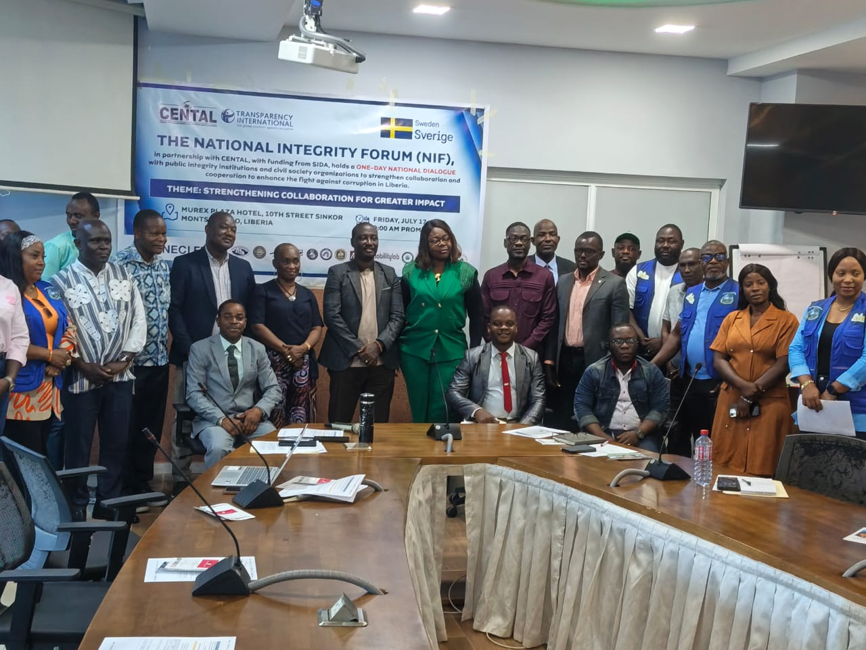
Appendix B: Dialogue Photos

