Liberia Extractive Industries Transparency Initiative Approved Annual Progress Report- 2025

Prepared by: LEITI Secretariat
Approved by: Multi-Stakeholder Group

Table of Contents
Acknowledgment 2
Acronyms 4
Background/Introduction 6
Executive Summary 6
I. Assessment of Performance against Target Activities in Work Plan 8
Employment in the Extractive Sector 10
WORKPLAN IMPLEMENTATION MATRIX FOR 2024 22
Assessment of Performance against EITI Requirement 25
Specific Strengths and Weaknesses identified in the EITI Process 65
Total Implementation Cost 66
Activities of the Broader Constituency of the MSG 66
Details of Membership of the MSG during the Period 70

Acknowledgment
The Liberia Extractive Industries Transparency Initiative (LEITI) Multi-Stakeholder Group (MSG) extends its heartfelt gratitude to all stakeholders who have worked tirelessly to achieve the milestones outlined in this 2025 Annual Activity Report.
To civil society organizations, we commend your unwavering advocacy, which remains a cornerstone of the EITI process in Liberia. Your active engagement ensures that the voices of ordinary Liberians are heard, promoting transparency and accountability in the extractive sector.
To the private sector, we recognize your steadfast commitment to disclosure requirements and sustainable investments. Your adherence to these principles strengthens Liberia's investment climate and enhances resource governance.
To the Government of Liberia, we sincerely appreciate your continued provision of an enabling environment that fosters progress in the EITI implementation process. Your support is critical to advancing resource transparency and accountability in the country.
We are equally grateful to our international partners, foreign governments, and development organizations, whose unwavering support has been instrumental in achieving key deliverables. In particular, we acknowledge the invaluable contributions of the World Bank, the African Development Bank (AfDB), and the GIZ for their consistent assistance in implementing LEITI work plans.
The role of ordinary Liberians cannot be overstated. Your active participation, particularly during nationwide dissemination exercises, has been pivotal in driving reforms that enhance resource governance. Your insights and feedback ensure that the EITI process remains inclusive and responsive to the needs of all Liberians.
The LEITI MSG also expresses profound gratitude to the EITI Secretariat, through its Regional Office for Anglophone Africa, for its consistent guidance and support. Your contributions, whether through training or technical advice, have been invaluable in navigating the complexities of EITI implementation.
To the dedicated staff of the LEITI Secretariat, we applaud your tireless efforts in managing the day-to-day intricacies of the EITI process. Your commitment, teamwork, and professionalism have been fundamental to LEITI’s sustained progress in promoting transparency and accountability in Liberia's extractive and other covered sectors.
Finally, we extend our most profound appreciation to His Excellency President Joseph N. Boakai for his leadership and unwavering commitment to the EITI process in Liberia. Your vision and dedication continue to positively shape the future of natural resource governance in our country.
Together, these collective efforts exemplify the power of collaboration and serve as a testament to Liberia’s commitment to building a transparent and accountable extractive sector that benefits all its citizens.

Map of Major Concessions in Liberia

Legend
Mining Concessions

Curtsey: National Investment Commission (NIC)
Agriculture Concessions

Acronyms
AfDB African Development Bank
AML ArcelorMittal Liberia
BOD Beneficial Ownership Disclosure
CBL Central Bank of Liberia
CENTAL Center for Transparency and Accountability in Liberia
COYPED Coalition of Youth for Peace and Development
DC Development Consortium
EITI Extractive Industries Transparency Initiative
EMW Extractive Media Watch
FDA Forestry Development Authority
FLY Federation of Liberian Youth
FY Fiscal Year
GAC General Auditing Commission
GC Governance Commission
GDP Gross Domestic Product
GIZ Gesellshaft fur Internationale Zusammenarbeit (German Int’l Development Agency)
GoL Government of Liberia
GVL Golden Veroleum Liberia
GODIMWUL Gold and Diamond Workers Union of Liberia
GYACN Global Youth Anti-Corruption Network
HOR House of Representatives
LACC Liberia Anti-Corruption Commission
LBR Liberia Business Registry
LEITI Liberia Extractive Industries Transparency Initiative
LMC Liberia Media Center
LRA Liberia Revenue Authority
LTA Liberia Timber Association
MDAs Mineral Development Agreements
MFDP Ministry of Finance and Development Planning
MOJ Ministry of Justice
MSG Multi-stakeholders Steering Group
MIA Ministry of Internal Affairs
MLME Ministry of Lands, Mines and Energy
MoA Ministry of Agriculture
NBC National Bureau of Concessions
NCB National Competitive Bidding
NCSCL National Civil Society Council of Liberia
NOCAL National Oil Company of Liberia
NTCL National Traditional Council of Liberia
ODI Overseas Development Initiative
PFM Public Financial Management
PPCC Public Procurement and Concession Commission
PWYP Publish What You Pay Coalition
REOI Request for Expression of Interest
RFQ Request for Quotation
SDF Social Development Fund
STOAP Strengthen Transparency, Oversight and Accountability Project
TOR Terms of Reference
UNMIL United Nations Missions in Liberia
USAID United States Agency for International Development
WONGOSOL Women NGO Secretariat of Liberia

Background/Introduction

Since joining the Extractive Industries Transparency Initiative (EITI) in 2007 and becoming the first African nation to achieve compliance in 2009, Liberia has remained a global leader in promoting transparency and accountability in natural resource governance. The Liberia Extractive Industries Transparency Initiative (LEITI), established by an Act of Legislature in 2009, brings together government, civil society, and private-sector stakeholders to ensure the responsible management of revenues from extractive resources, including mining, oil, gas, forestry, and agriculture.
With 16 EITI Reports published, Liberia continues to lead in EITI implementation. Notable achievements include being one of only two countries to legislate EITI implementation, expanding the initiative to encompass forestry and agriculture, pioneering a post-award process audit in 2013, and piloting beneficial ownership disclosure. These milestones underscore Liberia’s role as a trailblazer in global EITI efforts.
This Annual Activity Report for 2025 reflects the progress made in advancing EITI standards, assessing the outcomes of LEITI’s work, and strengthening natural resource governance. It highlights achievements against the 2024/2025 Workplan, progress toward meeting EITI requirements, and insights into the reporting period's strengths, challenges, and implementation costs.
As a testament to Liberia’s commitment to transparency, this report is developed in accordance with EITI Standard Requirement 7.2. It aims to provide stakeholders with a comprehensive overview of LEITI’s impact on the governance of the country’s natural resources.

Executive Summary
The Liberia Extractive Industries Transparency Initiative (LEITI), in alignment with its mandate to promote transparent and accountable resource management, implemented a series of strategic programs and activities throughout 2025. These initiatives, outlined in the LEITI 2024-2025 Work Plan, aimed to foster transparency, enhance stakeholder engagement, and strengthen governance within Liberia’s extractive sector. Despite significant financial and capacity constraints, the LEITI achieved a notable 85% completion rate for its planned activities.
Key Achievements and Activities:
- Enhancing Timely Communication and Public Awareness:
- Strengthened communication efforts to improve public understanding of EITI implementation and its impact.
- Promoted awareness campaigns to encourage active participation in resource governance discussions.
- Capacity Building for Effective EITI Implementation:
- Conducted targeted training sessions to build technical expertise among stakeholders for more effective EITI compliance and reporting.
- Conducted targeted trainings for forty women from twenty Civil Society Organizations to strengthen their capacity to improve advocacy around LEITI data.
- Conducted targeted training for members of the Multi-Stakeholder Group.
- Six staff members completed both national and International short-term trainings.
- Partnered with other civil society organizations to provide targeted training for some members of the National Legislature.
- Citizen Engagement in Resource Management:
- Facilitated public debates and consultations to empower citizens to participate in decision-making processes across the resource value chain.
- Production and Dissemination of EITI Reports:
- Produced Liberia’s 16th EITI Report, detailing the extractive sector’s contribution to the national budget for the 2023 fiscal year.
- Disseminated the 13th, 14th, and 15th EITI Reports to ensure broad access to critical sectoral information.
- Updated LEITI’s Simplified Contract Matrix.
- Commencement of a Compliance Investigation Report for six companies in the mining sector.
- Collaboration with Anti-Corruption Entities:
- Referral of suspected irregularities in the extractive sector to the Liberia Anti-Corruption Commission for deeper review.
- Creation of Reporting Mechanisms:
- LEITI MSG reviewed and approved the Data Portal and Reports.
- Sectoral Risk Assessments and Policy Reviews:
- Reviewed Liberia’s current energy policy and provided actionable recommendations for policy enhancement.
- Compliance and Impact Studies:
- Undertook compliance reviews of license renewals and concessions in the mining, forestry, agriculture, and oil and gas sectors to ensure adherence to contractual obligations.
- Strengthening County-Level Partnerships:
- Built partnerships at the county level to monitor and report on utilizing Social Development Funds (SDF), ensuring transparency and accountability in local resource management.
- Addressing Validation Corrective Actions:
- Developed a comprehensive work plan to address all corrective actions identified in the last EITI validation process, further solidifying Liberia’s commitment to EITI standards.
The implementation of the 2024-2025 Work Plan faced obstacles. Financial constraints, limited technical capacity, and systemic challenges posed significant hurdles. Nevertheless, LEITI’s determined efforts led to substantial progress, with most planned activities completed. This achievement underscores the Secretariat’s resilience and commitment to promoting transparency and accountability in Liberia’s extractive industries.
As the LEITI prepares for the coming year, it remains focused on advancing its strategic objectives, fostering stronger partnerships, and addressing remaining gaps in governance and transparency. Building on the successes of 2024, LEITI reaffirms its commitment to ensuring that Liberia’s natural resources contribute meaningfully to sustainable development and the well-being of all citizens.

I. Assessment of Performance against Target Activities in Work Plan
LEITI's annual work plans are customarily aligned with the Government’s fiscal term, which now runs from January to December.

The execution of the 2024-2025 work plan saw 85% percent of activities outlined in the work plan for the period achieved as presented below:

Launch of 16th EITI Report, Updated Simplified Contract Matrix and Data Portal
On December 12, 2025, the Liberia Multi-stakeholder arrangement launched the country’s 16th EITI Report, which reports total tax revenue of USD 152,460,000.00, along with the LEITI Updated Simplified Contract Matrix and Data Portal. Below are highlights of the report:
In March 2024, the MSG commissioned the production of Liberia’s 15th EITI Report, covering the fiscal period from July 1, 2021, to December 31, 2023. This report, produced under the traditional reconciliation framework, marks a significant milestone as the second reconciled report post-COVID-19. It captures data from 16 in-scope companies operating across three of the four covered sectors and ten government institutions.
Parker & Associates LLC, in collaboration with BDO-UK, was contracted to produce the 16th Report. The report aligns with EITI Requirements 2, 3, 4, 5, and 6, providing comprehensive contextual information on:
- Legal framework and fiscal regime
- Beneficial Ownership (BO) Disclosure
- Contract transparency
- The extractive sector’s contribution to the economy
- Production and export data
- Revenue allocations and state shareholdings
- License registers and allocations
- Anti-Corruption
- State shareholding in extractive entities
- Social and Environmental monitoring
- Energy Transition
- Artisanal and Small-Scale mining
The leading contributors to government revenue during the period were:
- Arcelor Mittal Liberia Limited: USD 60,022,089.00
- Bea Mountain Mining Company: USD 37,637,109.00
- Firestone Liberia Incorporated: USD 11,645,450.00
- Western Cluster- USD 10,299,451.00
- China Union- 9,625, 302.00
- Others- 23,228,301.00
Social and Environmental Expenditure:
- Total expenditures: USD 24,213,324 million
- Mandatory social spending: USD 11,908,679 million
- Voluntary social spending: USD 11,225,349 million
- Environmental expenditures: USD 1,079,296 million
Production and Export Overview:
Production volumes:
- Gold: 12,146 kilograms
- Iron Ore: 4,002,474 metric tons
- Diamonds: 56,838 carats
- Round Logs: 232,000 cubic meters
- Rubber: 77,055 tons
- Crude Palm Oil: 85,271 metric tons

Export Value
Total export value: USD 1.352 billion (99.23% of Liberia’s total exports)
Key contributors:
- Bea Mountain Mining Corporation: 55%
- Arcelor Mittal: 34%
- Firestone Liberia Incorporated: 11%

Employment in the Extractive Sector
Total employment: 19,345 workers (0.48% of Liberia’s labor force)
- Male representation: 16,637s
- Female representation: 2,708

Reporting Challenges
LEITI faced difficulties obtaining information from certain government institutions and companies, which hampered the reporting process. To address this:
- The MSG has mandated the enforcement of Regulations 001 during the production of the 16th EITI Report. Regulation 001 is the Liberian MSG sanction regime adopted in 2016.
- Delinquent entities will be publicly named and shamed to ensure compliance with EITI standards.
The Liberia Extractive Industries Transparency Initiative (LEITI) officially launched its 15th EITI Report on December 12, 2025, marking a pivotal step in advancing transparency and accountability in Liberia’s extractive sector. The report, covering the fiscal period from January 1, 2023, to December 31, 2023, was produced by Parker & Associates LLC in collaboration with BDO-UK under the Multi-Stakeholder Steering Group (MSG). This is Liberia's second reconciled report since the onset of the COVID-19 pandemic.
The report highlights key data from 16 in-scope companies across the mining, forestry, and agriculture sectors, as well as contributions from 10 government institutions. Total revenues from the extractive sector during the period totaled USD 152.46 million, representing 21.46% of Liberia’s domestic revenue. Top contributors included ArcelorMittal Liberia ($60,022,089.00), Bea Mountain Mining Company ($37,637,109.00), Firestone Liberia ($11,645,450.00), Western Cluster (10,299,451.00), China Union Liberia (9,625, 302.00), and others (23,228,301.00).
During the reporting period, export value amounted to USD 1.352 billion, representing 97.55% of the country’s total exports. Bea Mountain Mining Corporation led exports with 49%, followed by ArcelorMittal at 36% and Firestone Liberia 6%. Extractive companies' social and environmental expenditures totaled $24 million, of which $12 million was mandatory social spending.
The report also captures significant production data, including 12,146 kg of gold, 4,002,474 metric tons of iron ore, and 56,838 carats of diamonds. Employment figures showed 19,345 people employed in mining, agriculture, and forestry, with 14% of workers female.
In a landmark move, Liberia launched a digital Beneficial Ownership (BO) register in September 2023 to enhance accountability, combat corruption, and promote responsible business practices. The full register will be operational by March 2026.
While celebrating these achievements, LEITI acknowledged challenges, including non-compliance by some government institutions and companies in providing data for the report. To address this, the MSG has mandated stricter enforcement of regulations, including publicly naming and shaming delinquent entities in the forthcoming 17th and 18th EITI Reports.
Members of the MSG at the launch of the 16th EITI Report for Liberia
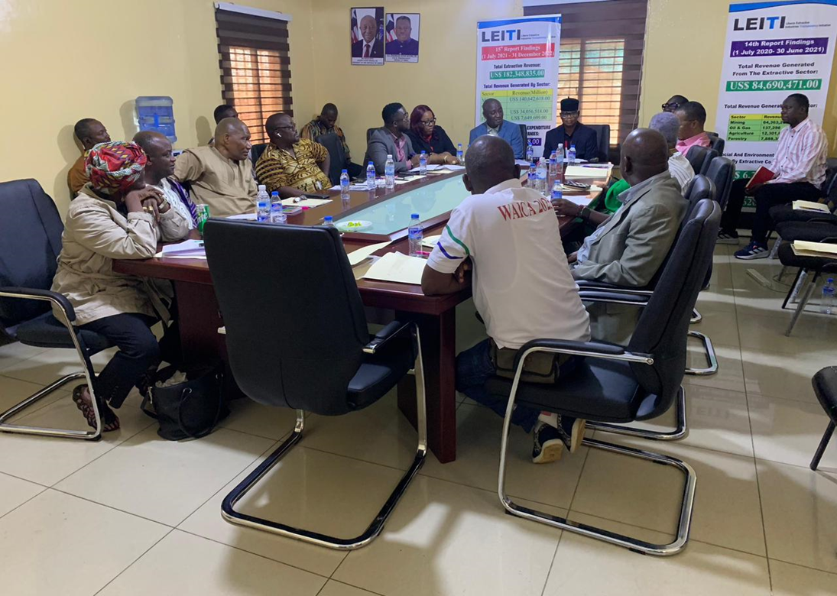
Dissemination of 13th, 14th and 15th EITI Reports
The Liberia Extractive Industries Transparency Initiative (LEITI), with valuable support from GIZ and the Government of Liberia, has officially launched the second phase of disseminating its 13th, 14th, and 15th EITI Reports throughout Liberia. This stage of the outreach program will extend to Sinoe, Margibi, Grand Bassa, and River Cess Counties, ensuring that vital information on the extractive sector is brought directly to citizens at the community level.
The rollout commenced in Sinoe County, where residents convened to review the findings of the reports and openly express their concerns. During these engagements, several pressing issues were highlighted by community members:
- Poor road infrastructure continues to hinder mobility, access to services, and overall development.
- Limited transparency and accountability in the management and utilization of Social Development Funds (SDFs).
- Insufficient employment opportunities for local populations within concession areas, leave many without sustainable livelihoods.
- Environmental degradation associated with mining activities, particularly in Government Camp.
- Uninformed extraction of black sand, with communities lacking awareness of its importance and potential benefits.
LEITI reaffirmed its commitment to fostering inclusive dialogue, enhancing data accessibility, and strengthening public awareness, all aligned with the EITI’s global principles of transparency and accountability in natural resource governance.
The LEITI Secretariat extends its heartfelt appreciation to GIZ and the Government of Liberia for its continued collaboration and support, which have been instrumental in advancing these outreach efforts. Together, LEITI and GIZ are making significant progress in ensuring that information about Liberia’s natural resources is not only published but also reaches the citizens who are most directly impacted.

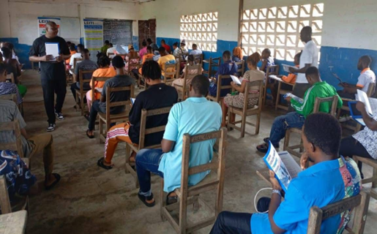
LEITI Team disseminating in Sinoe Country
Capacity building for effective EITI implementation
The push for greater transparency and accountability in Liberia's extractive industries took a significant step forward on November 14, 2024, as the Africa Center for Energy Policy (ACEP) and the Liberia Extractive Industries Transparency Initiative (LEITI) hosted a One-Day Training Workshop on Beneficial Ownership (BO) Transparency in Monrovia. To sharpen the skills of key stakeholders and address emerging challenges around beneficial ownership transparency, the event attracted more than 40 participants representing 20 institutions across government, civil society, and private companies.
The workshop emphasized the importance of empowering stakeholders with the knowledge and tools to identify and track the real individuals—beneficial owners—who ultimately control or profit from companies operating within Liberia’s extractive sector. As extractive industries such as mining, oil, and gas remain central to Liberia’s economy, ensuring transparency in ownership structures is critical to combating corruption and enhancing good governance. The event, guided by the Extractive Industries Transparency Initiative (EITI) principles, brought participants together to exchange ideas, share best practices, and discuss the steps needed to establish a robust, transparent beneficial ownership regime in Liberia.

Jeffrey Yates, Head of the LEITI secretariat, kicked off the workshop with a powerful message about the need for Liberians to take ownership of the beneficial ownership transparency process. He emphasized that while international frameworks and initiatives like EITI provide a strong foundation, the true success of any transparency efforts must come from within Liberia.

“For this process to succeed beyond the crafted frameworks and international efforts, Liberians must take ownership of the process with utmost patriotism,” Yates said. He stressed the importance of sustained engagement among all stakeholders to foster a national culture of transparency, in which beneficial ownership disclosure becomes a regulatory requirement and a deeply ingrained national priority. According to Yates, sustained dialogue and collaboration will be essential in overcoming the challenges that continue to impede progress.

One of the key themes of the workshop was the need for cross-sector collaboration to strengthen Liberia’s BO regime. Elias Ali, ACEP’s Policy Lead on Mineral and Mining, applauded Liberian stakeholders' willingness to confront corruption head-on, even amid structural and financial challenges.

“Liberian stakeholders have shown great commitment to fighting corruption through implementing a BO regime despite the numerous challenges they face,” Ali remarked. He reiterated ACEP’s commitment to working alongside LEITI and other partners to implement Liberia’s beneficial ownership system effectively. Ali noted that identifying the owners of companies operating in the extractive sector is crucial to preventing corruption, tax evasion, and illicit financial flows—issues that have long plagued resource-rich countries such as Liberia.

Ali’s comments highlighted the broader goal of beneficial ownership transparency: leveling the playing field by exposing the real actors behind corporate entities. This transparency prevents individuals with hidden interests from exploiting Liberia’s natural resources and ensures that the government and the public can hold companies accountable for their actions.

One significant challenge raised during the workshop was the need for institutional reform, particularly regarding the Liberia Business Registry (LBR), the country’s BO Register custodian. Mohammed Dukuly, Deputy Director General for Finance at the Liberia Petroleum Regulatory Authority (LPRA), delivered remarks urging the Liberian government to make a more substantial commitment to ensuring transparency in beneficial ownership. He urged the government to grant the Liberia Business Registry (LBR) the autonomy it needs to function effectively.

“The Liberia Business Registry, as the custodian of the country’s BO Register, cannot fully function without autonomy,” Dukuly stated. He pointed out the inherent conflict of interest in the current structure, where the LBR operates as a subset of the Ministry of Commerce. According to Dukuly, this arrangement compromises the LBR’s ability to act independently, a critical factor if Liberia is to build a reliable and transparent BO regime. He called for the LBR to be made an autonomous agency, free from the influence of any government ministry, to ensure that its mandate is carried out impartially.

The workshop concluded with a renewed sense of urgency and determination among stakeholders. The discussions made it clear that while Liberia has made strides in implementing beneficial ownership transparency, much work remains. Achieving complete transparency in corporate ownership, particularly in extractive industries, is no easy feat. However, with continued collaboration, stakeholder engagement, and the political will to enact necessary reforms, Liberia can move closer to a future in which its natural resources benefit all citizens, not just a select few. As the country navigates these challenges, the work of institutions like LEITI and ACEP, combined with support from civil society and the private sector, will be critical to ensuring the country’s resources are managed transparently and responsibly. Beneficial ownership transparency is not just a technical or legal issue—it is a vital step toward building a more accountable and just Liberia.

Following their revision, more robust BO software was developed and launched at the end of September. However, the team is still conducting testing with data users, providers, and collectors. The BO platform will be publicly available beginning December 1, 2023.
With the development and recent launch of Liberia's Beneficial Ownership (BO) Register, the Country has taken a meaningful step towards transparency in company ownership, especially in its extractive industries. The Register aims to help increase accountability in the Country's business sector, disclose the actual beneficial owners of corporate institutions, strengthen domestic resource mobilization, and greatly assist the Country in combating money laundering, illicit financial flows, fraud, corruption, and other financial or environmental crimes.


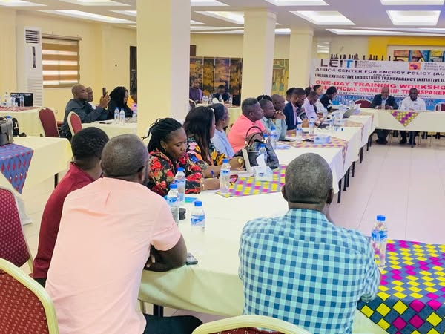
ACEP's representative, Eliasu Ali in remarks
Cross-section of stakeholders at the workshop in Monrovia
The Head of the LEITI Secretariat, making remarks
The LEITI Secretariat, as part of its MSG-approved work plan and to strengthen staff capacity to address the new 2023 EITI Standard, with funding from GIZ Liberia, sent two staff members for short-term international capacity-building in Ghana and Kenya. J. Elijah J. Kai, Sector/Industry Analyst, and Francis Kettor, Procurement Officer, benefited from the staff capacity building program. Elijah Kai attended a Data Analysis and Management training course using advanced Excel at Eriches Consult Limited in Nairobi, Kenya. At the same time, Francis Kettor obtained a certificate in proposal and contract negotiations from the Ghana Institute of Management and Public Administration (GIMPA). With support from the Government of Liberia, four staff members earned professional diplomas in Procurement and Supply Chain Management (Cythia Freeman), Monitoring and Evaluation (Cathrine Leon), Human Resource Management (Emmanuel K. White), and ICT (Kelvin Benson) from the African Methodist Episcopal University and Blue Crest University, respectively.

The training aims to strengthen the selected staff's skills in data analysis/management, interpretation, contract review, and implementation. These capacity-building activities align with our Institution's commitment to continuous learning and professional development.



Francis Kettor at GIMPA Elijah Kai receiving his certificate in Kenya

Cythia Freeman Emmanuel K. White Catherine Leon

LEITI Secretariat facilitates a one-day workshop on Understanding the EITI in Liberia and Beneficial Ownership

On May 30, 2025, the LEITI Secretariat brought together 40 women from 20 Civil Society Organizations to strengthen their capacity to advance advocacy on LEITI data. The workshop also aimed to increase women's participation in managing Liberia's extractive sector and to provide a platform for more gender-responsive EITI implementation.

Topics discussed included: Understanding the EITI and a glimpse into LEITI at work; Understanding the Beneficial Ownership Concept; and how women Civil Society Organizations can use LEITI's data to strengthen advocacy. Presenters included Zaza Y. Quaqua (Deputy Head of the Secretariat), McDonald Socrates Kerl (Technical Officer at the Secretariat), and Mrs. Decontee King Sackie (Former Deputy Commissioner General for Technical Services at the Liberia Revenue Authority). The key takeaway from the workshop includes the establishment of LEITI's women's advocacy platform to advance advocacy around LEITI data.

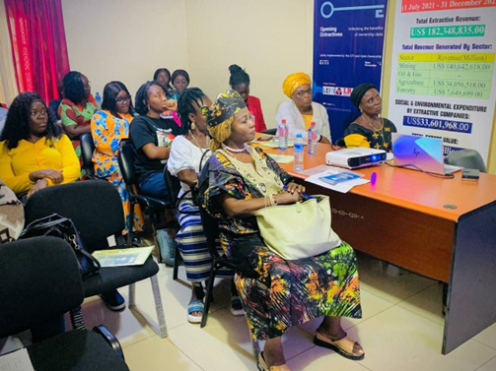
Pictorial highlights from the workshop
LEITI facilitates a two-day engagement with Community-Based Civil Society Organizations in Bong and Nimba counties
The 2023 EITI Standard requires implementing countries to engage CSOs beyond the MSG. The LEITI, in its usual effort to comply with the Standard, organized a two-day engagement with county-based CSOs in Bong and Nimba Counties to enable CSOs and the media to discuss how EITI data is relevant to their work on advocacy, civic engagement, and policy reform. The objective was to ensure stakeholders had access to and used EITI data for advocacy, to provide data-driven insights into the extractive sector, and to communicate real-time data to policymakers and communities affected by extractive sector operations. The dialogue sought to highlight the significant role CSOs and the media can play in engaging citizens using EITI data. The dialogue also provided a platform for CSOs to discuss Beneficial Ownership and Contract Transparency, social contributions, and the approaches LEITI could take to strengthen its anti-corruption drive under the new 2023 EITI Standard.

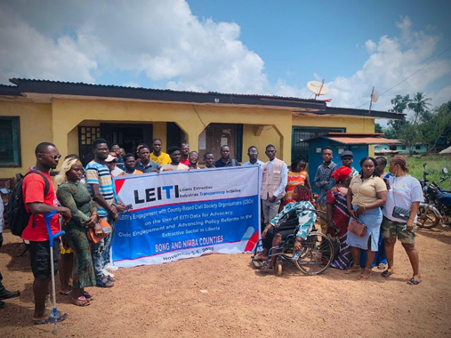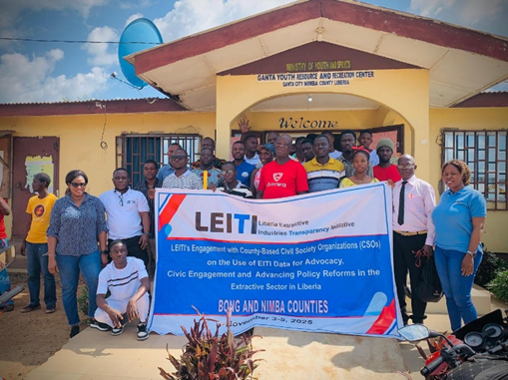

Collaboration with Anti-Corruption Entities
During the reporting period, LEITI continued to strengthen collaboration with accountability institutions through participation in activities marking the 2025 International Anti-Corruption Day, organized by the Liberia Anti-Corruption Commission (LACC) from December 8–9, 2025. On December 8, 2025, LEITI was represented at the National Anti-Corruption Day Symposium held in Buchanan, Grand Bassa County. The symposium brought together representatives of government institutions, the judiciary, civil society organizations, development partners, Integrity Institutions, and youth groups to discuss the theme “Uniting with Youth Against Corruption: Installing Integrity in our Future Leaders for a Peaceful, Inclusive and Prosperous Liberia.” Discussions were also centered on coordination among anti-corruption and justice actors, challenges in accountability processes, and practical pathways for youth engagement. Two LEITI staff members attended the symposium, and the LEITI Admin Manager served as Rapporteur for the first session, supporting documentation of key discussions and recommendations emerging from the deliberations.

The observance culminated on December 9, 2025, at the H.E. Ellen Johnson Sirleaf Ministerial Complex in Monrovia with commemorative activities comprising both outdoor and indoor programs. These included a parade, thematic presentations, anti-corruption messaging, cultural performances, and a youth-focused debate. Five LEITI staff members participated in the December 9 activities and attended both program segments, demonstrating LEITI’s continued institutional engagement in national transparency and anti-corruption initiatives.
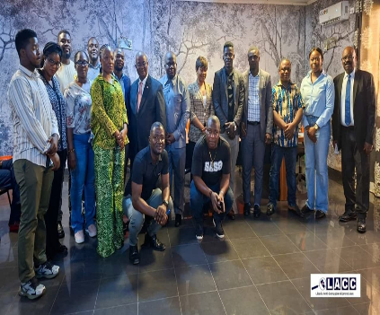
LEITI Staff members, along with other participants
LEITI Holds Year-end Retreat in Grand Bassa
From December 15-20, 2025, the members of the Multi-Stakeholder Group and the LEITI Secretariat staff assembled in Buchanan, Grand Bassa County, to review progress and challenges in the fiscal year 2025. During the retreat, the Multi-Stakeholder Group reviewed and approved the validation templates prepared by the Secretariat; reviewed and approved the LEITI Secretariat's five-year Strategy Plan; reviewed and approved the #2025 Annual Progress Report; and agreed on their priorities for the #2026 fiscal-year work plan. The key priority areas for fiscal year 2026, unanimously agreed upon by the MSG, are: strengthening Beneficial Ownership Disclosure; Anti-Corruption; innovative ways to strengthen Contract Transparency; Mainstreaming the EITI process in Liberia; Communications and Public awareness, Simplifying and improving the accessibility of LEITI data for better understanding; Improving disclosure and transparency around Artisanal and Small Scale Mining, and strengthening engagement with the National Legislature. These priority areas align with the Government of Liberia ARREST Agenda and the 2023 EITI Standard.

During the week of the retreat, the LEITI Secretariat hosted a debate between the Buchanan Open Bible Standard School and the Kpanay Town Public High School on the topic: Does revealing ultimate beneficial owners of extractive companies curtail illicit financial flows in the extractive sector? The Buchanan Open Bible Standard School supported the motion, while Kpanay Town Public High School opposed it. Buchanan Open Bible Standard School won the debate with 87%, while Kpanay Town Public High School had 71%.

The LEITI Secretariat also visited the Harlandsville Interactive Forum and disseminated key findings from its recently released 16th EITI Report. Participants were highly engaged and encouraged the LEITI Secretariat to regularly visit the county and center to provide key data on extractive companies operating there.

The retreat ended with renewed commitments from both the Multi-Stakeholder Group and the Secretariat staff.
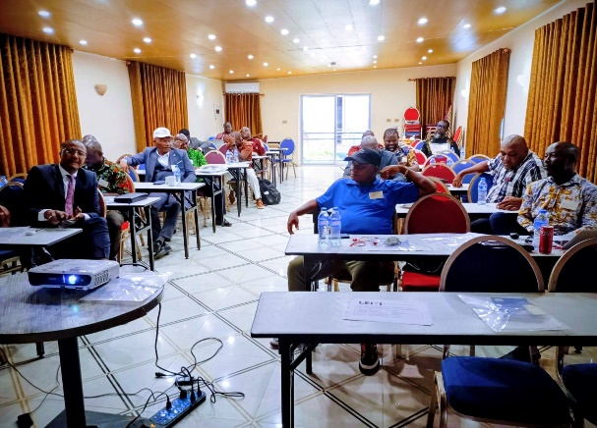
.
Pictorial of events at the retreat

Engagement with Students from Stella Maris Polyethnic University:
In support of LEITI’s outreach and communication plan, the Head of Secretariat, Jeffrey N. Yates, had the privilege of presenting to students at Catholic-run Stella Maris Polytechnic University today, March 27, 2025, upon the invitation of Mr. Dorsla Farcarthy, a lecturer.

The presentation focused on how the EITI Standard helps resource-rich countries maximize benefits from their natural resources while ensuring transparency and accountability. Key topics covered included the EITI Value Chain, the composition and role of the Multi-Stakeholder Group (MSG), LEITI’s progress toward Contract Transparency and Beneficial Ownership Transparency, and its contributions to policy reforms in Liberia’s extractive sector.

The session was highly interactive, with students showing great interest in LEITI’s activities. Many expressed appreciation for the Secretariat’s work and requested another engagement to gain deeper insights. They also showed enthusiasm about visiting the Secretariat to learn more. As part of its commitment to public awareness and stakeholder engagement, LEITI will continue its outreach to universities and high schools nationwide.

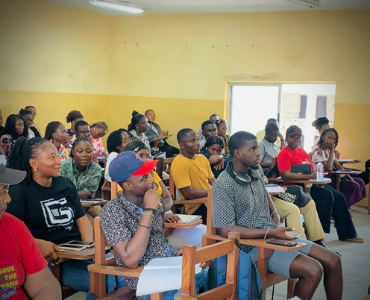
LEITI Head of Secretariat lecturing on Extractive Sector Governance at the University

Production of the 16th EITI Report
On December 12, 2025, Liberia’s Multi-Stakeholder Group (MSG), comprising representatives from government, the private sector, and civil society organizations, officially launched the country’s 16th Extractive Industries Transparency Initiative (EITI) Report. The report disclosed total tax revenues of USD 152,460,000.00 million, underscoring the extractive sector’s continued importance to national development.
On October 25, 2024, the MSG commissioned the preparation of the 16th Report, which covers the fiscal period from January 1 to December 31, 2023. Produced under the traditional reconciliation framework, this publication represents a significant milestone as Liberia’s second reconciled report in the post-COVID-19 era. It consolidates data from 16 in-scope companies operating across three of the four covered sectors, as well as contributions from 10 government institutions.
OBJECTIVE OF THE REPORT
The purpose of this 16th LEITI report is to compile and present the data provided by the extractive companies (hereinafter referred to as “companies”) in comparison with the relevant data provided by government agencies for effective governance of the extractive sector. The overall objective of this exercise is to assist the GoL in understanding the contributions of all extractive resources, including minerals, oil and gas, forestry, and agriculture, to the country’s economic and social development, and to enhance their potential through strengthened resource governance that fully adheres to the principles and requirements of the EITI.
REVENUE DATA
Consequently, LEITI 16th EITI report reveals that the total extractive sector revenue received by the Government from the Oil &Gas, Mining, Forestry, and Agriculture sectors for the period January 1, 2023, to December 31, 2023, amounted to One Hundred Fifty-Two Million Four Hundred Sixty Thousand United States Dollars (USD152,460,000.00).
Of this amount, the Mining sector contributed One Hundred Twenty-One Million Four Hundred Ninety Thousand United States Dollars (US$121,490,000.00), the agriculture sector contributed Twenty-Three Million Nine Hundred Seventy Thousand United States Dollars (US$23,970,000.00), the Forestry sector contributed Six Million Four Hundred Fifty Thousand United States Dollars (US$6,450,000.00), and the Oil and Gas sector contributed Five Hundred Fifty Thousand United States Dollars (US$550,000.00).
EXPORT DATA
Further analysis of the report indicates that a total of One Billion Three Hundred fifty-two million Seven Hundred Forty Thousand United States Dollars (1,352,740,000.00) worth of extractive commodities were exported during the period. Of this amount, gold exports totaled Six Hundred Sixty Million Three Hundred Forty Thousand United States Dollars (US$660,340,000).00), Iron Ore export amounted to Four Hundred Eighty Two Million Seven Hundred Thousand United States Dollars (US$482,700,000.00), Diamond export amounted to Seventeen Million Nine Hundred Ten Thousand United States Dollars (US$17,910,000.00), Rubber export amounted to One Hundred Three Million United States Dollars (US$103,000,000.00), Crude Palm Oil export amounted to Eighty Two Million Seven Hundred Ninety Thousand United States Dollars (US$82,790,000.00), amongst others.
The report reveals that Bea Mountain gold export value amounted to Six Hundred Ninety-One Million Two Hundred Fifty-Four Thousand Five Hundred Thirty-Nine United States Dollars (US$691,254,539.00), Western Cluster iron ore export value amounted to Ninety Three Million Four Hundred Eighty Three Thousand Two Hundred Ninety Four United States Dollars (US$93,483,294.00) and Arcelor Mittal iron ore export value amounted to Two Hundred Seventy One Million Fifty Three Thousand One Hundred Seventy One United States Dollars (US$271,053,171.00).

EMPLOYMENT DATA
The report also reveals that total employment in the extractive sector for the period was 19,345. Of this amount, 16,602 were males, while 2,743 were females. Further analysis shows that Bea Mountain had 1,110 permanent foreign employees during the period.

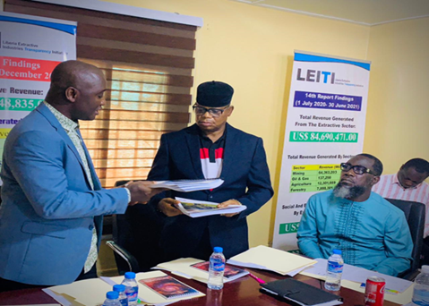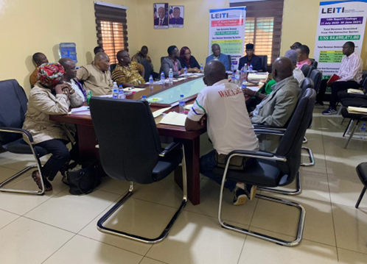
LEITI Head of Secretariat presents the 16th Report to the Chairman of the MSG

This data portal underscores LEITI’s dedication to leveraging technology to foster transparency and improve resource management outcomes for all Liberians.

WORKPLAN IMPLEMENTATION MATRIX FOR 2024
Workplan Description | Implementation Year | Status
Enhance citizens' debate and participation in decisions around resource extraction along the value chain; | 2025
Address emerging and existing challenges facing Liberia's EITI implementation in Liberia, such as Gender Mainstreaming, Environmental and Social Issues, Anti-Corruption, Energy Transition, Contract Transparency, Beneficial Ownership, etc.; | 2025
Dissemination of LEITI’s 13th, 14th, and 15th EITI Reports. | 2025
Enhancing Timely Communication and Public Awareness for Effective EITI Implementation | 2025
Providing evidence-based information to the Executive and Legislative branches of Government for informed decision-making to ensure citizens' benefits and | 2025
Capacity building for effective EITI implementation | 2025
Enhance citizens' debate and participation in decisions around resource extraction along the value chain; | 2025
Production of Liberia's 16th EITI Report, which will show the contribution of the extractive sector to the national budget for the period 2023. | 2025
Study on the Social, Environmental, and Economic impacts of small-scale mining, forestry, and agriculture activities on women, youths, and other disadvantaged groups in selected counties; | 2025
The creation and popularization of a hotline at the Secretariat exclusively to receive, document, and forward to the Liberia Anti-Corruption and the Ministry of Justice corruption-related offenses; | 2025
Built partnerships at the county level to monitor and report on utilizing Social Development Funds (SDF), ensuring transparency and accountability in local resource management. | 2025
Conduct a risk assessment on the awarding of licenses in the ASM sector. | 2025
Conduct/ Document Liberia's current energy policy and recommend areas for improvement; | 2025
Develop a work plan that addresses all the corrective actions from the last validation. | 2025
Conduct a study on the Social, Environmental, and Economic impacts of small-scale mining, forestry, and agriculture activities on women, youths, and other disadvantaged groups in selected counties; | 2025
Conduct a Compliance review of License Renewal in the Mining, Forestry, Agriculture, and Oil & Gas Sectors; | 2025
Development of LEITI Data Portal | 2025
Production of LEITI Updated Simplified Contract Matrix | 2025
Produced and published the LEITI Service Delivery Charter | 2025
Conduct a Compliance review of concessionaires/concessions in the Mining, Forestry, Agriculture, and Oil & Gas Sectors, among others. | 2025

LEGEND
Not Started

Work in Progress
Completed

The above table illustrates that the LEITI Secretariat achieved 85% of its workplan activities for 2025

Assessment of Performance against EITI Requirement
During the reviewed period, Liberia produced and launched the 15th EITI Report and disseminated it along with the 13th and 14th reports to six of the 15 political subdivisions of Liberia. Below is an assessment of LEITI’s performance against the EITI Requirements for the period under review using the previous 15th Report:
Requirement | Progress
1.1 Government engagement.  Requirement 1.1(a)  The government is required to issue an unequivocal public statement of its intention to implement the EITI. The head must make the statement of state or government or an appropriately delegated government representative.  Requirement 1.1(b)  The government is required to appoint a senior individual to lead the implementation of the EITI. The appointee should have the confidence of all stakeholders, the authority, and the freedom to coordinate action on the EITI across relevant ministries and agencies and mobilize resources for EITI implementation.  Requirement 1.1(c )  The government must be fully, actively, and effectively engaged in the EITI process.  Requirement 1.1 (d)  The government must ensure that senior government officials are represented in the multi-stakeholder group. | In February 2024, when a new MSG was appointed, Liberia’s President H.E. Jospeh N. Boakai tasked the new members to implement the EITI in Liberia scrupulously.  President Joseph Boakai also appointed Hon. Wilmot J.M. Paye, Minister of Mines, as Chair of the MSG and Hon. Augustine K. Ngafuan, Minister of Finance and Development Planning, as Co-Chair. However, Minister Paye was replaced by Minister R. Matenokay Tingban.  The MSG regularly met during the period under review. There was a quorum at all these meetings with the government at the senior and middle levels.  The government’s composition on the MSG is represented at the senior level. For example, the former and current chairpersons of the MSG presided over all MSG meetings. At the same time, the Deputy Minister for Fiscal Affairs regularly represented the Minister of Finance and Development Planning.
1.2 Company engagement.  Requirement 1.2 (a)  Companies must be fully, actively, and effectively engaged in the EITI process.  Requirement 1.2 (b)  The government must ensure an enabling environment for company participation concerning relevant laws, regulations, administrative rules, and actual practice in implementing the EITI. The fundamental rights of company representatives substantively engaged in the EITI, including but not restricted to multi-stakeholder group members, must be respected.  Requirement 1.2 ( c)  The government must ensure no obstacles to company participation in the EITI process. | The reviewed period witnessed the full participation of companies in the EITI process as respective constituents’ representatives attended MSG meetings and contributed to consensual decision-making, especially in approving the workplan and TOR for the 16th EITI Report, Updated Simplified Contract Matrix and Compliance Investigation Reports.  Under Article 6.4C of the LEITI Act, the industry is guaranteed at least four seats in the MSG, including at least one seat each for companies in the mining, forestry, agriculture, and oil and gas sectors. The current MSG comprises Golden Veroleum, an oil palm developer, representing agriculture; the Liberia Chamber of Mines, representing mining; the Liberia Timber Association, representing forestry; and the Liberia Business Association, representing the Oil and Gas sector. Senior-level managers represent all of these. During the period under review, the private sector’s participation was well documented through the meeting minutes, and there was no incidence of coercion.  Decision-making on the MSG is by consensus. In instances where consensus-building cannot hold, MSG members, including CSOs and companies, have the right to vote without molestation or harassment. However, the review period saw a level playing field for companies’ representation on the MSG. All decisions taken during the reporting period were reached through consensus-building
1.3 Civil Society Engagement  Requirement 1.3 (a)  Civil society must be fully, actively, and effectively engaged in the EITI process.  Requirement 1.3 (b)  The government must ensure an enabling environment for civil society participation concerning relevant laws, regulations, administrative rules, and actual practice in implementing the EITI. The fundamental rights of civil society substantively engaged in the EITI, including but not restricted to members of the multi-stakeholder group, must be respected.  Requirement 1.3 (c )  The government must ensure no obstacles to civil society participation in the EITI process.  Requirement 1.3 (d)  The government must refrain from actions that narrow or restrict public debate concerning implementing the EITI.  Requirement 1.3 (e) Stakeholders, including but not limited to multi-stakeholder group members, must: i. Be able to speak freely on transparency and natural resource governance issues. ii. Be substantially engaged in the design, implementation, monitoring, and evaluation of the EITI process, and ensure that it contributes to public debate. iii. Have the right to communicate and cooperate. iv. Be able to freely express opinions about the EITI without restraint, coercion, or reprisal. | CSOs are an integral part of the LEITI, backed by an Act of 2009. One of the specific objectives of LEITI, according to Article 3.2(a) of the LEITI Act, is “to promote the effective participation of civil society in the design, implementation, evaluation, and modification of actions, activities, processes and institutional arrangements associated with resource governance in Liberia.” There were CSO representations in all monthly, call, and committee meetings during the reviewed period. CSOs made significant contributions to the development of LEITI’s workplan, approval of the 16^{th,} EITI Report, Updated Simplified Contract Matrix, and Compliance Investigations TORs, along with the reports themselves. All of the LEITI dissemination exercises included Civil Society Organizations.  Civil society organizations’ involvement in the LEITI process is legal through legislation.  Civil society organizations’ involvement in the LEITI process is legal through legislation. CSOs. Civil society is fully engaged in designing, implementing, monitoring, and evaluating the EITI process. CSOs participated in outreach to promote public debate, particularly at the county level. There is an enabling environment for civil society participation in the EITI.
Requirement (1.4)  Multi-stakeholder group.  a) The government must commit to working with civil society and companies and establish a multi-stakeholder group to oversee the implementation of the EITI. In establishing the multi-stakeholder group, the government must:  i. Ensure that the invitation to participate in the group is open and transparent.  ii. Ensure that stakeholders are adequately represented. This does not mean that they need to be equally represented numerically. The multi-stakeholder group must comprise appropriate stakeholders, including but not necessarily limited to: the private sector; civil society, including independent civil society groups and other civil society such as the media and unions; and relevant government entities, which can also include parliamentarians. Each stakeholder group must have the right to appoint its representatives, bearing in mind the desirability of pluralistic and diverse representation. The nomination process must be independent and free from any suggestion of coercion. Civil society groups involved in the EITI as multi-stakeholder group members must be operationally and, in policy terms, independent of government and/or companies.  iii. Consider establishing the legal basis of the group.  b) The multi-stakeholder group must agree to clear public Terms of Reference (ToRs) for its work. The ToRs should, at a minimum, include provisions on:  The role, responsibilities, and rights of the multi-stakeholder group:  i. Members of the multi-stakeholder group should have the capacity to carry out their duties.  ii. The multi-stakeholder group should undertake effective outreach activities with civil society groups and companies, including through media, websites, and letters, informing stakeholders of the government’s commitment to implementing the EITI and the central role of companies and civil society. The multi-stakeholder group should also widely disseminate public information from the EITI process, such as the EITI Report.  iii. Members of the multi-stakeholder group should liaise with their constituency groups. Approval of work plans, EITI Reports, and annual activity reports:  iv. The multi-stakeholder group is required to approve annual work plans, the appointment of the Independent Administrator, the Terms of Reference for the Independent Administrator, EITI Reports, and the yearly activity report.  v. The multi-stakeholder group should oversee the EITI reporting process and engage in Validation. Internal governance rules and procedures:  vi. The EITI requires an inclusive decision-making process throughout implementation, with each constituency being treated as a partner. Any member of the multi-stakeholder group has the right to table an issue for discussion. The multi-stakeholder group should agree and publish its procedures for nominating and changing multi-stakeholder group representatives, decision-making, the duration of the mandate, and the frequency of meetings. This should include ensuring that there is a process for changing group members that respects the principles set out in  Requirement (1.4.a.)  The MSG has per diems for attending EITI meetings or other payments to MSG members; this practice should be transparent and not create conflicts of interest.  vii. There should be sufficient advance notice of meetings and timely circulation of documents before their debate and proposed adoption.  viii. The multi-stakeholder group must keep written records of its discussions and decisions | The MSG has been formed and includes appointed representatives from each stakeholder group. While the President appoints all MSG members, the private sector and civil society organizations constituencies independently made the selection/elections. There was public outreach ahead of the selection of CSO and Private Sector members of the MSG, and the ToR for the MSG addresses the requirements of the EITI Standard. Attendance of MSG members is at varying levels, with a delegation of attendance to different representatives being common, particularly for government and industry. There is evidence that critical documents were shared with MSG representatives for comments, most of which were shared with the broader constituencies.  From December 12-15, 2025, the MSG held a retreat in Buchanan City, Grand Bassa County, approving the validation templates, LEITI five-year strategy plan, LEITI annual progress report, along with setting the priorities for the fiscal year 2026.  During the recent appointment of the MSG, the Executive Mansion held constructive and coordinated consultations with the private sector and civil society constituencies on the selection/election of their respective representations with no coercion. The LEITI Secretariat has documentation leading to these exercises.  With instruction from the MSG, the LEITI Secretariat has documented all meeting minutes of the Body for the period under review.
Requirement 1.5  Work plan. The multi-stakeholder group is required to maintain a current work plan, fully cost and aligned with the reporting and Validation deadlines established by the EITI Board. The work plan must:  a) Set EITI implementation objectives linked to the EITI Principles and reflect national priorities for the extractive industries. Multi-stakeholder groups are encouraged to explore innovative approaches to extending EITI implementation to increase the comprehensiveness of EITI reporting and public understanding of revenues and promote high standards of transparency and accountability in public life, government operations, and business.  b) Reflect the results of consultations with key stakeholders and be endorsed by the multi-stakeholder group.  c) Include measurable and time-bound activities to achieve the agreed objectives. The scope of EITI implementation should be tailored to contribute to the objectives identified during the consultation process. The work plan must:  i. Assess and outline plans to address potential capacity constraints in government agencies, companies, and civil society that may hinder effective EITI implementation.  ii. Address the scope of EITI reporting, including plans for addressing technical reporting aspects, such as comprehensiveness and data reliability (Requirements 4.1 and 4.9).  iii. Identify and outline plans to address any potential legal or regulatory obstacles to EITI implementation, including, if applicable, any plans to incorporate the EITI Requirements within national legislation or regulation.  iv. Outline the multi-stakeholder group’s plans for implementing Validation and EITI reporting recommendations.  d) Identify domestic and external funding sources and technical assistance where appropriate to ensure timely implementation of the agreed work plan.  e) Be made widely available to the public, for example, published on the national EITI website and/or other relevant ministry and agency websites, in print media, or in places that are easily accessible to the public.  f) Be reviewed and updated annually. In reviewing the work plan, the multi-stakeholder group should consider extending the detail and scope of EITI reporting, including addressing issues such as revenue management and expenditure (5.3), transportation payments (4.4), discretionary social expenses (6.1.b), ad-hoc sub-national transfers (5.2.b), beneficial ownership (2.5) and contracts (2.4).  Under Requirement 1.4.b (viii), the multi-stakeholder group must document its discussion and decisions.  g) Include a timetable for implementation aligned with the reporting and Validation deadlines established by the EITI Board (see provision 8), which considers administrative requirements such as procurement processes and funding. | During the reviewed period and in keeping with Requirement 1.5, LEITI prepared a two-year well-costed workplan driven by substantive and collective inputs from MSG members and stakeholders outside the MSG. The two-year workplan covered January 1, 2024, to December 31, 2025. The workplan encompasses deliverables to achieve the EITI Standard Act of 2009 and conforms to the ARREST, the nation’s overarching development plan.  Key deliverables of the 2024-2025 work plan are the preparation of the 15th and 16th EITI Reports on Liberia, the restructuring of the LEITI website and social media outlets, the Establishment of Beneficial Ownership (BO) Register for BO regime implementation, Facilitate Liberia’s EITI Mainstreaming process for efficient and effective reporting. Significant progress was made towards the achievements of the outlined. All approved decisions came from the MSG in their sittings and consensus-building, meaning every sector made inputs that impacted these decisions.  As MSG meeting minutes, all decisions reached are recorded and uploaded to the LEITI website.  During the period under review, the MSG approved a comprehensive roadmap for addressing corrective actions from the last validation.  During the period under review, while discussing and approving the inception reports for the 15th and 16th EITI reports, agreed on key measures to take to ensure data comprehensiveness and reliability.  Not Applicable  During the period under review, the MSG approved a comprehensive roadmap for addressing corrective actions from the last validation.  During the period under review, the MSG clearly identified funding sources in its work plans to support EITI implementation.  During the period under review, all LEITI work plans were publicly available on its websites and Facebook page.  All meetings of the Body are clearly documented and posted on the LEITI Secretariat website for public access.  All LEITI Workplans are time-bound with clear objectives.
Requirement 2: Legal and institutional framework, including allocating contracts and licenses.  Requirement 2.1  Legal framework and fiscal regime.  a) Implementing countries must disclose a description of the legal framework and fiscal regime governing the extractive industries. This information must include a summary description of the fiscal regime, including the level of fiscal devolution, an overview of the relevant laws and regulations, and information on the roles and responsibilities of the appropriate government agencies.  b) Where the government is undertaking reforms, the multi-stakeholder group is encouraged to be documented.  Requirement (2.2)  License allocations.  a) Implementing countries are required to disclose the following information related to the award or transfer of licenses about the companies covered in the EITI Report during the accounting period covered by the EITI Report: i., a description of the process for transferring or awarding the license; ii. the technical and financial criteria used; iii. information about the recipient(s) of the license that has been transferred or awarded, including consortium members where applicable; and iv. any non-trivial deviations from the applicable legal and regulatory framework governing license transfers and awards. It is required that the information set out above is disclosed for all license awards and transfers during the accounting year covered by the EITI Report, including license allocations about companies that are not included in the EITI Report, i.e., where their payments fall below the agreed materiality threshold. Any significant legal or practical barriers preventing such comprehensive disclosure should be documented and explained in the EITI Report, including an account of government plans for overcoming such barriers and the anticipated timescale for achieving them.  b) Where companies covered in the EITI Report hold licenses allocated before the accounting period of the EITI Report, implementing countries are encouraged, if feasible, to disclose the information set out in 2.2(a) for these licenses.  c) Where licenses are awarded through a bidding process during the accounting period covered by the EITI Report, the government is required to disclose the list of applicants and the bid criteria.  d) Where the requisite information set out in 2.2(a-c) is already publicly available, including a reference or link in the EITI Report is sufficient.  e) The multi-stakeholder group may wish to include additional information on the allocation of licenses in the EITI Report, including commentary on the efficiency and effectiveness of licensing procedures.  Requirement (2.3)  Register of licenses.  a) The term license in this context refers to any license, lease, title, permit contract or concession by which the government confers on a company(ies) or individual(s) rights to explore or exploit oil, gas, and/or mineral resources.  b) Implementing countries are required to maintain a publicly available register or cadastre system(s) with the following timely and comprehensive information regarding each of the licenses about companies covered in the EITI Report: i. License holder(s). ii. Where collated, coordinates of the license area. Where coordinates are not collated, the government must ensure that the license area's size and location are disclosed in the license register and that the coordinates are publicly available from the relevant government agency without unreasonable fees and restrictions. The EITI Report should include guidance on accessing the coordinates and the data's cost if any. The EITI Report should also document plans and timelines for making this information freely and electronically available through the license register. iii. Date of application, date of award, and duration of the license. iv. In the case of production licenses, the commodity is produced. It is expected that the license register or cadastre includes information about licenses held by all entities, including companies and individuals or groups that are not included in the EITI Report, i.e., where their payments fall below the agreed materiality threshold. Any significant legal or practical barriers preventing such comprehensive disclosure should be documented and explained in the EITI Report, including an account of government plans for seeking to overcome such barriers and the anticipated timescale for achieving them.  c) Where the information set out in 2.3.b is already publicly available, it is sufficient to include a reference or link in the EITI Report. Where such registers or cadastres do not exist or are incomplete, the EITI Report should disclose any gaps in the publicly available information and document efforts to strengthen these systems. In the interim, the EITI Report should include the information in 2.3.b above.  Requirement (2.4)  Contracts.  a) Implementing countries are encouraged to publicly disclose any contracts and licenses that provide the terms attached to the exploitation of oil, gas, and minerals. b) It is required that the EITI Report documents the government’s policy on disclosing contracts and licenses governing oil, gas, and minerals exploration and exploitation. This should include relevant legal provisions, actual disclosure practices, and any planned or underway reforms. Where applicable, the EITI Report should provide an overview of the contracts and licenses that are publicly available and include a reference or link to the location where these are published. c) The term contract in 2.4(a) means i. The full text of any contract, concession, production-sharing agreement or other agreement is granted or entered into. The government provides the terms for exploiting oil, gas, and mineral resources. ii. The full text of any annex, appendix, or rider establishes details relevant to the exploitation rights described in 2.4(c)(i) or execution. iii. The full text of any alteration or amendment to the documents described in 2.4(c)(i) and 2.4(c)(ii). d) The term license in 2.4(a) means i. The full text of any license, lease, title, or permit by which a government confers on a company (ies) or individual(s) rights to exploit oil, gas, and/or mineral resources. ii. The full text of any annex, appendix, or rider establishes details relevant to the exploitation rights described in 2.4(d)(i) or execution. ii. The full text of any alteration or amendment to the documents described in 2.4(d)(i) and 2.4(d)(ii).  Requirement (2.5)  Beneficial ownership. a) It is recommended that implementing countries maintain a publicly available register of the beneficial owners of the corporate entity (ies) that bid for, operate, or invest in extractive assets, including the identity (ies) of their beneficial owner(s), the level of ownership and details about how ownership or control is exerted. Where possible, beneficial ownership information should be incorporated in existing filings by companies to corporate regulators, stock exchanges, or agencies regulating extractive industry licensing. Where this information is already publicly available, the EITI Report should include guidance on how to access this information  b) It is required that i. The EITI Report documents the government’s policy and MSG’s discussion on beneficial ownership disclosure. This should include details of the relevant legal provisions, actual disclosure practices, and any planned or underway reforms related to beneficial ownership disclosure. ii. By 1 January 2017, the multi-stakeholder group publishes a roadmap for disclosing beneficial ownership information under clauses (c)-(f) below. The MSG will determine all milestones and deadlines in the roadmap, and the MSG will evaluate the implementation of the roadmap as part of the MSG’s annual activity report. c) As of 1 January 2020, it is required that implementing countries request and companies disclose beneficial ownership information for inclusion in the EITI report. This applies to a corporate entity (ies) that bid for, operate, or invest in extractive assets and should include the identity(ies) of their beneficial owner(s), the level of ownership, and details about how ownership or control is exerted. Any gaps or weaknesses in reporting on beneficial ownership information must be disclosed in the EITI Report, including naming entities that failed to submit all or parts of the beneficial ownership information. A country facing constitutional or significant practical barriers to implementing this requirement by 1 January 2020 may seek adapted implementation under requirement d) Information about the beneficial owner's identity should include the beneficial owner's name, nationality, country of residence, and identifying any politically exposed persons. It is also recommended that the national identity number, date of birth, residential or service address, and means of contact are disclosed. e) The multi-stakeholder group should agree on an approach for participating companies assuring the accuracy of the beneficial ownership information they provide. This could include requiring companies to attest to the beneficial ownership declaration form through sign-off by a member of the senior management team or senior legal counsel or submit supporting documentation. f) Definition of beneficial ownership: i. A beneficial owner in a company means the natural person(s) who directly or indirectly ultimately owns or controls the corporate entity. ii. The multi-stakeholder group should agree on an appropriate definition of the beneficial owner. The definition should be aligned with (f)(i) above and take international norms and relevant national laws into account, and should include ownership threshold(s). The definition should also specify reporting obligations for politically exposed persons. iii. Publicly listed companies, including wholly-owned subsidiaries, are required to disclose the stock exchange name and include a link to the stock exchange filings where they are listed. iv. In the case of joint ventures, each entity within the venture should disclose its beneficial owner(s) unless it is publicly listed or is a wholly-owned subsidiary of a publicly listed company. Each entity is responsible for the accuracy of the information provided. g) The EITI Report should also disclose such companies' legal owners and share of ownership.  Requirement (2.6)  State participation. Where state participation in the extractive industries gives rise to material revenue payments, implementing countries must disclose: a) An explanation of the prevailing rules and practices regarding the financial relationship between the government and state-owned enterprises (SOEs), e.g., the rules and practices governing transfers of funds between the SOE(s) and the state, retained earnings, reinvestment, and third-party financing. For EITI reporting, an SOE is a wholly or majority government-owned company engaged in extractive activities on behalf of the government. Based on this, the MSGs are encouraged to discuss and document their definition of SOEs, taking national laws and government structures into account. b) Disclosures from the government and SOE(s) of their level of ownership in mining, oil, and gas companies operating within the country’s oil, gas, and mining sector, including those held by SOE subsidiaries and joint ventures and any changes in the level of ownership during the reporting period. This information should include details regarding the terms attached to their equity stake, including their responsibility to cover expenses at various phases of the project cycle, e.g., full-paid equity, free equity, and carried interest. Where there have been government and SOE(s) ownership level changes during the EITI reporting period, the government and SOE(s) are expected to disclose the transaction terms, including details regarding valuation and revenues. Where the government and SOE(s) have provided loans or loan guarantees to mining, oil, and gas companies operating within the country, details on these transactions should be disclosed | Legal Framework (Mining Sector)  The Ministry of Mines and Energy (MME) is the Government Agency responsible for administering the mineral sector, including granting mining licenses, and it has statutory oversight of the energy, land, minerals, and water sectors. The minerals sector is regulated by the Mining and Minerals Law of 2000. The Minerals Policy of Liberia was created in March 2010 to complement the Mining and Minerals Law. The document outlines the Government’s expectations concerning the contributions of all stakeholders in the sustainable development of Liberia’s mineral resources. These laws are under review.  Exports and rough diamonds are overseen by the Government Diamond Office (GDO) within MLME and the Bureau of Customs.  Fiscal Regime (Mining Sector)  The fiscal regime specific to mining companies is set out in the Liberia Revenue Code (LRC) from sections 701 to 739. The central taxes paid by a mining company are a tax on taxable income (30%), royalties (Iron ore. 4.5% | Gold and other base metals. 3% | Commercial diamonds. 5 %.), and surface rent ((A) Land within a mineral exploration license area: USD 0.20 per acre. (B) Land within mining license are (i) Year 1-10 USD 5.00 per acre (ii) Year 11-25 USD 10.00 per acre).  Legal Framework (Oil and Gas Industry)  Current Legal framework (12th report page 44)  The central legislation governing oil & gas exploration and production activities in Liberia:  - New Petroleum Law of Liberia, 2014 (adopted 05 October 2016)11;  - National petroleum policy 201212; and  - National Oil Company of Liberia Act 2014,  According to the National petroleum policy, 2012, the Government of Liberia shall adhere to the principles and procedures of the Liberia Extractive Industry Transparency Initiative (LEITI). It shall comply with reporting and other requirements of this initiative and further transparency and accountability initiatives undertaken by the Government. The principles of LEITI applicable to the petroleum sector include others, disaggregated reporting on all material payments, requiring all petroleum companies to join LEITI, conducting reconciliations of company payments and Government receipts, and publishing contracts, concessions licenses, and audit reports. According to article 43 of the Petroleum (Exploration and Production) Reform Law of Liberia 2014, contractors shall engage in and comply with the requirements of LEITI under the LEITI Act and the directives and guidelines approved by the LEITI Multi-stakeholder Steering Group (MSG). In particular, a contractor shall disclose to the LEITI reconcilers on an accurate and timely basis and in the required manner all payments made to the State, including any Government Agency and a state-owned company, and shall provide the said reconcilers with such information and documents as they may reasonably require for investigating any discrepancies and preparing the LEITI reports.  Fiscal Regime (Oil and Gas)  The fiscal regime specific to the oil & gas sector is set by Liberia's Petroleum (Exploration and Production) Reform Law 20141617. The primary revenue streams paid by oil & gas companies are royalties, surface rentals, bonuses, and exceptional contributions.  Legal Framework (Agriculture Sector)  The Ministry of Agriculture (MoA) is responsible for the leadership and overall development of the agricultural sector. With agricultural concessions, MoA works closely with the National Investment Commission (NIC) to identify investors interested in investing in the sector. Once an investor has been identified, the President of Liberia, at the request of NIC, establishes an Inter-Ministerial Concession Committee (IMCC) to review, negotiate and present a Concession Agreement for approval and signing by the President and ratification by the Honorable Legislature.  Fiscal Regime (Agriculture Sector)  The fiscal regime specific for agricultural companies is set out in the LRC from sections 600 to 699. The main taxes paid by an agricultural company are Taxes on Taxable Income (Renewable Resources: 25% and Rice: 15%) and Surface Rental (USD 2 per acre for developed land and USD 1 per acre for undeveloped land, irrespective of the value of the assets contained thereon).  Legal Framework (Forestry Sector)  Apart from the Public Procurement and Concession Agreement (PPCA) 2010, specific regulations that apply to the Forestry Sector are • Act creating the Forestry Development Authority (FDA) of 1976; • National Forestry Reform Law of 2006; • Forestry Core Regulations - FDA Ten Core Regulations (effective September 2007); • Act to Establish the Community Rights Law concerning Forest Lands of 2009; • FDA Regulations to the Community Rights Law concerning Forest Lands, July 2011; • Guidelines for Forest Management Planning in Liberia; and • National Forest Management Strategy, 2007.  Fiscal Regime (Forestry Sector)  The main taxes paid by a forestry company are taxes on taxable income (25%) and Log Export Fees (These are fees associated with the export of logs as a forest product), Area Fee (These are fees associated with the use of Forest Land, including administrative fees and area-based fees tied to the resource licensees.), Forest Product Fee (processed materials) Stumpage Fee (These fixed fees were prescribed by regulations issued by FDA in consultation with the Minister, and assessed by FDA and paid regularly to the Minister for deposit into the account of Government. It is associated with the production, registration, transport, transfer of ownership, use, or export of forest products); Sawmill Permit Fees (Sawmill operators are classified into three (3) categories. Class A, B, and C. Class A operators process 1,500 cubic meters of wood annually and must pay USD 2,500 per annum. Class B operators are those who process 750 cubic meters of wood. Still, less than 1,500 and are to pay USD 1,000 annually, and class C Operators process less than 750 cubic meters of wood per year and are to pay USD 750 for the permit); Timber Export License Fees (This is a payment made to the government for a short-term forest Resource license issued by the government under section 5.3 of the National Forestry Reform law that allows the license holder to manage a tract of forest land and harvest or use forest products.  Mining Rights Allocation  There is a strict requirement that a person shall not prospect for minerals or carry on mining operations or mineral processing operations without the authority of a mining right or mineral processing license granted under the Minerals and Mining Law (2000). The Minister of Mines and Energy ensures that the law and regulations are appropriately administered.  The Minister of Mines and Energy shall grant a prospecting license to all eligible applicants for an area specified in the application if the application complies with the requirements outlined in the law or regulations.  The following are types of mineral rights/licenses that can be granted under the Minerals and Mining Law in Liberia: a) Prospecting License - it is granted when an area has not already been subject to a valid Mineral right granted to another person; the area granted shall not exceed one hundred (100) acres. The holder shall file and submit a proposed work plan for the prospection to the Minister of Mines and Energy. The Prospecting license does not give the right to conduct commercial mining. This is valid for six (6) months, renewable once for six (6) months, provided that the holder meets his obligations under the law.  b) Exploration License is granted when the area has not already been subject to a valid mineral right granted to another person; the exploration area shall be contiguous and shall not exceed one thousand (1,000) square kilometers. The holder is to submit a proposed exploration Programme to the Minister of Mines and Energy within ninety (90) days after the issuance of the exploration license and shall commence exploration within one hundred and eighty (180) days after the issuance of an exploration license unless the Minister agrees to a longer period. This is valid for not more than three (3) years, and it may be extended for a single two (2) year term upon the written application of a holder.  c) Class C mining license - the production area covered by this license shall be not more than twenty-five (25) acres. One person may simultaneously hold up to four (4) class C mining licenses. Holders of Class C mining licenses shall conduct mining predominantly as small-scale operations. This is valid for one (1) year, renewable for further terms of one year each if the holder has met all of his legal obligations.  d) Class B mining license - holders of class B mining licenses can conduct mining as industrial operations. The production area is twenty-five (25) acres, and this is valid for five (5) years and renewable for not more than five (5) years.  e) Class A mining license is granted during or at the end of the exploration period of discovering exploitable deposits. It is materially in compliance with a Mineral Development Agreement, which has become effective, permitting mining in the proposed production area. Not be more than twenty-five (25) years and may be extended for consecutive additional terms not exceeding twenty-five (25) years each.  The 15th and 16th EITI reports, prepared during the referenced period, provide a list of active licenses in Liberia's mining, oil, agriculture, and forestry sectors.  Liberia has developed an open data policy that conforms to Requirement 4.1. Though the LEITI MSG did not develop the policy, the MSG, through a resolution signed in December 2021, adopted an existing open data policy from the Government of Liberia, developed by the Liberia Institute for Statistics and Geo-information Service (LISGIS)  Following a successful pilot of the beneficial ownership disclosure in 2016, the country developed a beneficial ownership roadmap during the reviewed period. With the guidance and rich inputs of the MSG, Liberia’s BO Roadmap charts future courses of action to maintain an up-to-date beneficial ownership disclosure by 2022. This effort was further boosted on September 21, 2021, when Liberia launched the Open Extractives program to disclose beneficial owners of concessions in Liberia. LEITI is currently working with the Liberia Revenue Authority (LRA) and other relevant agencies to test templates and software, setting up a registry for Liberia in 2022.  A National Beneficial Ownership Regulation for Domestic Entities has been developed.  To ensure compliance, the MSG during the period ensured the disclosure of the full text of all Mineral Development Agreements on the website of the LEITI Secretariat, the disclosure of the full text of all Class B, Exploration and Prospecting Licenses on the website of the LEITI Secretariat, the listing of all active Class C licenses on the website of the LEITI Secretariat, the disclosure of all forestry and agriculture agreements on the website of the LEITI, and developed a policy for the disclosure of extractive sector licenses and contracts in Liberia.  The MSG also published an Updated Simplified Contract Matrix and commissioned a Compliance Investigation of six mining companies.  In August 2023, Liberia adopted new BO regulation134 which require companies to disclose information about their beneficial or ultimate owners in a new central register, including names, addresses, and ownership stakes.  The purpose of this regulation is to provide for the basis for the application of matters on beneficial ownership disclosure as prescribed by the Associations Law of Liberia, Title 5. Specifically, this Regulation provides the basis for the collection, processing, verification, publication, and accessibility to the information of beneficial owners of all entities that are created, organized, registered, or incorporated under the laws of the Republic of Liberia as well as foreign entities, businesses and companies that are authorized to do business within Liberia. The Regulation also prescribes sanctions for non-compliance.  From LEITI’s 12th report until the latest, there information on beneficial ownership. However, Liberia is launched a BO register which operationalization is underway.  Also, Liberia published a National Beneficial Ownership Regulation for Domestic Entities, preliminarily launched its National Beneficial Ownership Registry, established a National Steering Committee on Beneficial Ownership Implementation, Developed Guidance Notes, Developed a Multi-Pronged Beneficial Ownership Workplan, LEITI has included on its data portal segments for the collection of legal and beneficial owners, and continued capacity building for relevant stakeholders.  NOCAL is the only state-owned enterprise (SOE) operating in Liberia's oil & gas sector. NOCAL was set up in April 2000 by Liberia’s National Legislature for the purpose of holding all of the rights, titles, and interests of the Republic of Liberia in the deposits and reserves of liquid and gaseous  hydrocarbons within the territorial limits of the Republic of Liberia, whether potential, proven, or actual, to facilitate the development of the oil and gas industry in the Republic of  Liberia.” The new petroleum law (Exploration and production) of 2014 indicates that the primary activities of NOCAL shall be the ownership and management of petroleum rights acquired by NOCAL according to petroleum agreements or production-sharing agreements whether as the sole participant or in conjunction with others and the conduct of such other petroleum operations on behalf of the State  As may from time to time be authorized by the Authority.  The new petroleum law (Exploration and production) of 2014 spelled out. Regulatory power has been transferred from NOCAL to the Liberia Petroleum Regulatory Authority (LPRA), which means licenses registry, production sharing contracts, bid Rounds, and contract awards are now handled by the LRPA. NOCAL now plays a commercial role instead.” The New Petroleum Act 2014 added that NOCAL should have the following additional functions:  (a) manage all participating interests in petroleum agreements acquired under citizen participation  provisions of any petroleum agreement or production sharing agreement;  (b) manage any contracts entered into by the State for the construction or operation of petroleum facilities used in petroleum operations that are to be owned by the State or required to be operated by the State;  (c) own or manage other assets of any kind, necessary or useful in conducting commercial petroleum activities carried out by NOCAL according to this Act and the NOCAL Act;  (d) lift and market the State's entitlements of petroleum on account of the State's share of production according to the production sharing provisions of a petroleum agreement or production sharing agreement in the event such share is taken in kind under Section 31(1) of this Act;  (e) lift and market on behalf of any citizen’s participation interest referred to in clause (a) of this subsection 10.1, the petroleum shares accruing to such citizen’s participation interest;  (f) conduct or contract for and supervise, in compliance with Part IV of this Act, such geological, geophysical, and other technical studies as it may deem useful; and  (g) provide such technical assistance and advice as the Authority may request.  NOCAL may also participate in reconnaissance, exploration, development, and production activities in other jurisdictions at such time as it may have the resources and funds to do so.  Paragraph 14.1 of the Amended Petroleum Law 2019 (an Act to amend specific provisions of the new  The Petroleum (Exploration & Production) Reform Law of 2014 stipulates that LPRA shall grant petroleum.  Rights to NOCAL through Executive allocation in consultation with the National Legislature. The President shall announce a 100% interest allocation in a block to NOCAL through executive allocation.  Thereafter, NOCAL shall exercise its commercial options to operate the block solely and divest some of its interest in the block through farm-outs, etc. The President shall do the executive allocation, and the Authority shall carry out a pre-qualification list of companies presented by NOCAL. The SOE shall have the option to develop these petroleum acreages on its own or in partnership with any oil company through farm-ins by tender or direct negotiations. All Production Sharing or other agreements executed as a result of Executive Allocations shall be submitted to the Legislature for  Ratification. NOCAL also chairs the Hydrocarbon Technical Committee (HTC), the inter-ministerial body established under the 2002 Petroleum Law and empowered to negotiate all contracts.  NOCAL has embarked on a vigorous seismic data promotion and marketing campaign to encourage new exploration and ensure that companies hold oil exploration blocks so they can proceed with their respective work programs as quickly as possible over the last few years. This program includes  Data studies followed by detailed 3D seismic led to the identification of drillable structures and the exploratory drilling program.
Requirement 3 Exploration and Production  Requirement (3.1)  Exploration. Implementing countries should disclose an overview of the extractive industries, including any significant exploration activities.  3.2 Production. Implementing countries must disclose production data for the fiscal year covered by the EITI Report, including total production volumes, the value of production by commodity, and, when relevant, state/region. This could include sources of the production data and information on how the production volumes and values disclosed in the EITI Report have been calculated.  3.3 Exports. Implementing countries must disclose export data for the fiscal year covered by the EITI Report, including total export volumes, the value of exports by commodity, and, when relevant, by state/region of origin. This could include sources of the export data and information on how the export volumes and values disclosed in the EITI Report have been calculated. | Contextual information about the extractive industries in accordance with EITI Requirements 2, 3, 4, 5, and 6. This information includes a summary of the legal framework and fiscal regime; an overview of the extractive sector; the extractive industries’ contribution to the economy; production and export data; the State’s shareholdings in extractive entities; revenue allocations; license registers; and license allocations.  Production and export data information are provided in the LEITI 15th and 16th EITI Reports.
Requirement 4 Revenue Collection  4.1 Comprehensive disclosure of taxes and revenues. a) In advance of the reporting process, the multi-stakeholder group is required to agree on which payments and revenues are material. It, therefore, must be disclosed, including appropriate materiality definitions and thresholds. Payments and revenues are considered material if their omission or misstatement could significantly affect the comprehensiveness of the EITI Report. A description of each revenue stream, related materiality definitions, and thresholds should be disclosed. In establishing materiality definitions and thresholds, the multi-stakeholder group should consider the size of the revenue streams relative to total revenues. The multi-stakeholder group should document the options and rationale for establishing the definitions and thresholds. b) The following revenue streams should be included: i. The host government’s production entitlement (such as profit oil) ii. National state-owned company production entitlement iii. Profits taxes iv. Royalties v. Dividends vi. Bonuses, such as signature, discovery, and production bonuses vii. License fees, rental fees, entry fees, and other considerations for licenses and/or concessions viii. Any other significant payments and material benefit to the government. Any revenue streams or benefits should only be excluded where they are not applicable or where the multi-stakeholder group agrees that their omission will not materially affect the comprehensiveness of the EITI Report. c) Implementing countries must comprehensively reconcile government revenues and company payments under the agreed scope, including payments to and from state-owned enterprises. All companies making material payments to the government must comprehensively disclose these payments under the agreed scope. An entity should only be exempted from reporting if it can be demonstrated that its payments and revenues are not material. All government entities receiving material revenues must comprehensively disclose these revenues according to the agreed scope.  d) Unless there are significant practical barriers, the government is additionally required to provide aggregate information about the total revenues received from each benefit stream agreed in the scope of the EITI Report, including payments that fall below-agreed materiality thresholds. The Independent Administrator should draw on relevant data and estimates from other sources to comprehensively account for the total government revenues where this data is unavailable.  4.2 Sale of the state’s share of production or other revenues collected in-kind. Where the sale of the state’s share of production or other revenues collected in-kind is material, the government, including state-owned enterprises, is required to disclose the volumes sold and revenues received. The published data must be disaggregated by individual buying companies and commensurate with other payments and revenue streams (Requirement 4.7.). Reporting could also break down disclosures by product type, price, market, and sale volume. Where practically feasible, the multi-stakeholder group is encouraged to task the Independent Administrator with reconciling the volumes sold and revenues received by including the buying companies in the reporting process.  4.3 Infrastructure provisions and barter arrangements. The multi-stakeholder group and the Independent Administrator are required to consider whether there are any agreements or sets of agreements involving the provision of goods and services (including loans, grants, and infrastructure works) in full or partial exchange for oil, gas, or mining exploration or production concessions or physical delivery of such commodities. To be able to do so, the multi-stakeholder group and the Independent Administrator need to gain a full understanding of the terms of the relevant agreements and contracts, the parties involved, the resources which the state has pledged, the value of the balancing benefit stream (e.g., infrastructure works), and the materiality of these agreements relative to conventional contracts. The multi-stakeholder group concludes that these agreements are material. The multi-stakeholder group and the Independent Administrator are required to ensure that the EITI Report addresses these agreements, providing a level of detail and transparency commensurate with the disclosure and reconciliation of other payments and revenue streams. Where reconciliation of key transactions is not feasible, the multi-stakeholder group should agree on an approach for unilateral disclosure by the parties to the agreement(s) to be included in the EITI Report.  4.4 Transportation revenues. Where revenues from the transportation of oil, gas, and minerals are material, the government and state-owned enterprises (SOEs) are expected to disclose the revenues received. The published data must be disaggregated to levels commensurate with other payments and revenue streams (Requirement 4.7.). Implementing countries could disclose i. A description of the transportation arrangements, including the product, transportation route(s), and the relevant companies and government entities involved in transportation, including SOE(s). ii. Definitions of the relevant transportation taxes, tariffs, or other relevant payments and the methodologies used to calculate them. iii. Disclosure of tariff rates and volume of the transported commodities. iv. Disclosure of revenues received by government entities and SOE(s) concerning oil, gas, and minerals transportation. v. Where practicable, the multi-stakeholder group is encouraged to task the Independent Administrator with reconciling material payments and revenues associated with oil, gas, and minerals transportation.  4.5 Transactions related to State-owned enterprises (SOEs). The multi-stakeholder group must ensure that the reporting process comprehensively addresses the role of SOEs, including material payments to SOEs from oil, gas, and mining companies and transfers between SOEs and other government agencies.  4.6 Sub-national payments. It is required that the multi-stakeholder group establish whether direct payments, within the scope of the agreed benefit streams, from companies to subnational government entities are material. Where material, the multi-stakeholder group is required to ensure that company payments to subnational government entities and the receipt are disclosed and reconciled in the EITI Report.  4.7 Level of disaggregation. The multi-stakeholder group is required to agree on the disaggregation level for the data publication. It is required that individual companies, government entities, and revenue streams present EITI data. Reporting at the project level is required, provided it is consistent with the United States Securities and Exchange Commission rules and the future European Union requirements.  4.8 Data timeliness. a) Implementing countries must produce their first EITI Report within 18 months of being admitted as an EITI Candidate. After that, implementing countries are expected to produce EITI Reports annually. b) Implementing countries must disclose data no older than the second to last complete accounting period, e.g., an EITI Report published in the calendar/the financial year 2016 must be based on data no later than the calendar/financial year 2014. Multi-stakeholder groups are encouraged to explore opportunities to disclose data as soon as possible, for example, through continuous online disclosures or, where available, by publishing additional, more recent contextual EITI data than the accounting period covered by the EITI revenue data. If EITI reporting is significantly delayed, the multi-stakeholder group should take steps to ensure that EITI Reports are issued for the intervening reporting periods so that every year is subject to reporting. c) The multi-stakeholder group is required to agree to the accounting period covered by the EITI Report.  4.9 Data quality and assurance. a) The EITI requires assessing whether the payments and revenues are subject to credible, independent audit, applying international auditing standards. b) It is required that payments and revenues be reconciled by a credible, independent administrator, applying international auditing standards and the administrator’s opinion regarding that reconciliation, including discrepancies, should any be identified. i. The reconciliation of company payments and government revenues must be undertaken by an Independent Administrator applying international professional standards. ii. The multi-stakeholder group must perceive the Independent Administrator as credible, trustworthy, and technically competent. The multi-stakeholder group should endorse the appointment of the Independent Administrator. iii. The multi-stakeholder group and the Independent Administrator must agree to the Terms of Reference for the EITI Report based on the standard Terms of Reference and the ‘agreed-upon procedure for EITI Reports’3 endorsed by the EITI Board. Should the multi-stakeholder group wish to adapt or deviate from these agreed-upon procedures, approval from the EITI Board must be sought in advance (Requirement 8.1). c) Where the assessment in 4.9(a) concludes that there is (i) routine disclosure of the data required by the EITI Standard in requisite detail, and (ii) that the financial data is subject to credible, independent audit, applying international standards, the multi-stakeholder group may seek Board approval to mainstream EITI implementation under the ‘Agreed upon procedure for mainstreamed disclosures.’4 Without such prior approval, adherence to 4.9.b is required. | Based on recommendation outlined in the LEITI Scoping Report, the MSG agreed to the following agencies will, where appropriate, submit payment and contextual information for LEITI 15th and 16th reports. Contextual information will include employment, production, exports, licenses, barter and infrastructure, state participation, etc. While revenue information will include tax streams recommended by the Independent Administrator in both reports.  To ensure comprehensiveness of companies’ disclosures, the MSG agreed that on the following count of companies to submit production, exports, employment, voluntary and environmental expenditure data.  The Petroleum (Exploration and Production) Act (PEPA) is the primary legislation for the oil and gas sector in Liberia. It establishes a fiscal and legal regulatory framework for the management and regulation of petroleum activities in accordance with Articles 7 and 22(b) of the Constitution of the Republic of Liberia. Specifically, it provides the basis for ownership of petroleum and petroleum rights; institutional arrangements, including the establishment of NOCAL and LPRA; licensing, tendering for and granting of petroleum agreements; definition of forms and types of petroleum agreement, state participation; citizen participation; environmental health and safety; and local content and participation. Under the original law, the allocation of petroleum rights was only to be conducted through international competitive tendering. However, in 2019 the law was amended to include allocation of rights through direct negotiations with potential investors and executive allocation to NOCAL. In addition, new blocks were configured in the same year to align with international standards.  The National Oil Company of Liberia (Act) 2000 and as Amended in 2014. The Law establishes NOCAL as the national oil company with the mandate to engage in petroleum exploration, development and production on behalf of the State; lift and mar et State’s entitlement of crude petroleum taken in-kind; hold and manage all interests acquired by the State in all Petroleum agreements or production sharing agreements; and encourage the development of national capabilities in all aspects of petroleum exploration, development and production, among other things.  The Petroleum (Exploration and Production) Law and the Minerals and Mining Act, 2000 provides the legal basis for the State’ participation in the oil and gas and mining sectors respectively. In the oil and Gas sector State is entitled to 10 percent free interest under all Petroleum Agreements. In addition to this, the State has the right to acquire additional 5 percent citizen participation managed by NOCAL. Whiles the Petroleum law requires a total of 15 percent carried interest, the model PSC published by NOCAL intents a total of 10 percent carried interest for the State. Similarly, in the mining sector the government is entitled to free equity interest of not less than 10 percent and not more than 15 percent.  Under the new Petroleum (Exploration and Production) Act, NOCALs role has been restated. NOCAL is expected to play a more commercial role whiles its original regulatory roles have been transferred to the Liberian Petroleum Regulatory Authority. The new functions of NOCAL include:  The National Oil Company of Liberia (NOCAL) operates as a state-owned enterprise. However, oil has not been discovered in commercial quantity; hence, no production occurs in the industry, and the state’s share of production is not applicable.  As mentioned earlier in this paper, the reviewed period assessed Liberia’s compliance with the EITI standard. According to the initial assessment report, there is an infrastructure arrangement between the Government of Liberia and Arcelor Mittal relative to refurbishing a 243km railway from Tokadeh to Buchanan and the Buchanan mineral port. The MDA was initially signed in 2005 and amended in December 2006 and September 2013, with the infrastructure developed as a build-operate-maintain concession where ownership remained with the government.  .  No subnational transfers were recorded during the reviewed period, and this requirement does not apply to Liberia.  The MSG while approving the inception report, agreed with the Independent Administrator proposal to ensure the disaggregation of EITI data by project. However, there is no project reporting in Liberia.  The launched of LEITI 16th EITI Report for the fiscal year 2023 illustrates that the MSG is current with its EITI report in line with the Standard.  BDO, in collaboration with HLB, prepared Liberia’s EITI 15th and 16th EITI reports. The IA was hired through a competitive process guided by Liberia’s Public Procurement and Concession Law. To comply with EITI Requirement 4.9 and to ensure the credibility of the data submitted, the IA set the following:  - For each company, the “Payment/Receipt Report” should be signed off by an authorized senior official (at the board level); - for each Government Agency, the “Payment/Receipt Report” must be signed off by an authorized senior officer; and  - - each Reporting Template must be certified by an external auditor: •  Extractive companies and NOCAL: are required to obtain confirmations from a registered external auditor that the figures reported in the Reporting Templates are under instructions issued by LEITI, are complete, and are in agreement with the accounts for the period under review; and  • Government Agencies: are required to obtain confirmation from the Auditor General that the transactions reported in the Reporting Templates are under instructions issued by LEITI, are complete, and are in agreement with the accounts of government for the period under review.  - extractive companies were encouraged to submit their audited 2023 financial statements; and  - The Auditor General was required to carry out agreed-upon procedures under international standards in his certification of reporting templates provided by Government Agencies. For any changes to the information provided on the original data collection templates, supporting documents, and/or confirmation from reporting entities will have to be made available to the IA.  Instructions were developed, including reporting templates and reporting guidelines, requesting extractive companies and government agencies to report all required data. The technical workshop during which the IA presented the following: • reconciliation process; • reconciliation scope; • reporting templates and instructions; • lessons learnt from other reconciliation processes; and • reconciliation issues. The reporting package, including the RTs and the instructions for their completion, was sent electronically to the reporting entities. Extractive companies and government agencies were required to report directly to the IA, to whom they were also requested to direct any queries about the RTs.  The LEITI MSG agreed to include the mining, agricultural, and forestry sectors in the reconciliation scope. Based on the revenue structures collected by the LRA, the LEITI MSG agreed to include six (4) mining companies, six (5) agricultural companies and nine (5) forestry companies, which held active licenses during the period from 1 January 2023 to 31 December 2023 and which made payments over the materiality threshold of S 1,000,000 for the mining and agricultural sectors and S 100,000 for the forestry sector.  To ensure that EITI data submitted by reporting entities had been subject to credible, independent audits, applying international standards on auditing, the LEITI MSG agreed on the following approach about the reporting process by Government Agencies and extractive companies included in the LEITI reporting scope:  ✓ the declarations made by companies and government agencies should be signed by an authorized senior officer (at management level) and an authorized senior official, respectively;  ✓ the RTs submitted by government agencies included in the reporting scope, certified by the GAC, who should agree with the government accounts for the reporting period 2023; and  ✓ the RTs submitted by the extractive companies included in the reporting scope should be certified by an external auditor or the statutory auditor for each company; and  ✓ All extractive reporting entities selected in the reporting scope would be required to submit their audited financial statements for the reporting period 2023.
5.1 Distribution of extractive industry revenues. Implementing countries must disclose a description of the distribution of revenues from the extractive industries. a) Implementing countries should indicate which extractive industry revenues are recorded in the national budget, whether cash or in-kind. Where revenues are not recorded in the national budget, the allocation of these revenues must be explained, with links provided to relevant financial reports as applicable, e.g., sovereign wealth and development funds, sub-national governments, state-owned enterprises, and other extra-budgetary entities. b) Multi-stakeholder groups are encouraged to reference national revenue classification systems and international standards such as the IMF Government Finance Statistics Manual.  5.2 Subnational transfers. a) Where transfers between national and sub-national government entities are related to revenues generated by the extractive industries and are mandated by a national constitution, statute, or other revenue-sharing mechanisms, the multi-stakeholder group is required to ensure that material transfers are disclosed. Implementing countries should disclose the revenue-sharing formula and any discrepancies between the transfer amount calculated under the relevant revenue-sharing formula and the actual amount transferred between the central government and each relevant subnational entity. The multi-stakeholder group is encouraged to reconcile these transfers. Where there are constitutional or significant practical barriers to the participation of sub-national government entities, the multi-stakeholder group may seek adapted implementation under Requirement 8.1. b) The multi-stakeholder group is encouraged to ensure that any material discretionary or ad-hoc transfers are disclosed and reconciled where possible.  5.3 Revenue management and expenditures. The multi-stakeholder group is encouraged to disclose further information on revenue management and expenditures, including a) A description of any extractive revenues earmarked for specific programs or geographic regions. This should include a description of the methods for ensuring accountability and efficiency. b) A description of the country’s budget and audit processes and links to the publicly available information on budgeting, expenditures, and audit reports. c) Timely information from the government that will further public understanding and debate around revenue sustainability and resource dependence issues. This may include the assumptions underpinning forthcoming years in the budget cycle and relating to projected production, commodity prices, revenue forecasts arising from the extractive industries, and the proportion of future fiscal revenues expected from the extractive sector. | The Public Financial Management Act of 2009 represents the legal framework for reforming the institutions and processes involved in the financial and economic governance of Liberia. Section 8.1 of the PFM Law of 2009 and its implementing regulations require that the national budget be prepared “in the context of a medium-term fiscal framework for the purposes of achieving national objectives over a multi-year period”.  The budget process in Liberia is supported by a legal and regulatory framework – the Public Financial Management (PFM) Act of 2009,124 coupled with the Medium-Term Expenditure Framework (MTEF) Budgeting Manual. The Public Financial Management Act of 2009 establishes the legal framework for reforming the institutions and processes governing Liberia's financial and economic governance.  The overall purpose of the budget preparation phase is to produce a policy-focused National Budget that allocates scarce resources as efficiently and effectively as possible. There are two phases of the MTEF budget preparation process: - - Strategic phase: the overall purpose is to work on policies: Both fiscal policy and service delivery policy and priorities. Operational phase: the overall purpose is to develop detailed budgets for each spending entity, based on the agreed priorities established during the strategic phase.  A subnational transfer does not apply to Liberia, and none occurred during the review period.  Liberia operates an Open Budget Initiative (OBI), which requires a budget framework paper to support the national budget. The requirements for the Budget Framework Paper are set out in Section 11 of the PFM Act of 2009 and Part D.6 of the Associated Regulations, as follows:  1. The Proposed National Budget to be presented to the Legislature shall be accompanied by the budget framework paper, as outlined in Section 11 of the PFM Act of 2009, updated to reflect the draft budget submitted to the Legislature.  2. The budget framework paper shall contain the following: i. an analysis of the economic and fiscal trends and the assumptions underlying the budget's medium-term macroeconomic and fiscal framework; ii. an explanation of the government’s policy priorities and how these are reflected in the budget; iii. a statement of key financial risks that may affect budget execution; iv. the essential features of the medium term expenditure framework, where this has been prepared; v. a summary statement of revenues and expenditure performance, using the main economic categories identified in Section 8(d) of the PFM Act of 2009, for the last two years showing the surplus or deficit in each of the years, and indicating the use to which it was put (in the case of surplus) or the means of financing (in the case of deficit); vi. a summary statement of revenues and expenditures, using the main economic categories identified in Section 8(d) of the PFM Act of 2009, for the three years showing the projected surplus or deficit in each of the years, and indicating the use to which it will be put (in the case of surplus) or the means of financing (in the case of deficit); vii. a summary statement of off‐budget donor funding showing name of project and program, funding agency, recipient Government Agency, disbursements effected in the previous financial year, projected disbursement in the following financial year; viii. a summary statement of the performance of State‐Owned Enterprises (SOE) and their annual financial plans for the following year showing revenues, expenditures, and changes in net worth; ix. a summary statement of the performance of public corporations and Special Funds showing incomes accruing to them including any donor funding, cash flow statement, outstanding debt if any that includes arrears to vendors and borrowing requirements for the following financial year; x. a summary statement of budgetary implications of new legislation on the proposed budget as well as the financial implication over the two outer years, consistent with the provisions of Section 19 of the PFM Act of 2009.  3. The detailed annual budget estimates shall show the previous budget year outturns, the current year’s original budget, and the year‐to‐date outturn based on available data and projected outturns.  4. The detailed estimates, including revenues and expenditures, will be structured according to the classifications specified in Section 8(d) of the PFM Act of 2009. 5. The detailed estimates will include overall and agency-level summaries by the various classifications utilized in the budget. To strengthen the link between national priorities in the national development plan and the budget, the MTEF sets out two phases: strategic and operational. The strategic phase reviews priorities and strategies before detailed resource allocation. The operational phase of budget preparation involves allocating resources to sectors and spending entities and concludes with the national legislature passing the national budget.
6.1 Social expenditures by extractive companies. a) Where material social expenditures by companies are mandated by law or the contract with the government that governs the extractive investment, implementing countries must disclose and, where possible, reconcile these transactions. Where such benefits are provided in-kind, it is required that implementing countries disclose the nature and the deemed value of the in-kind transaction. Where the beneficiary of the mandated social expenditure is a third party, i.e., not a government agency, it is required that the name and function of the beneficiary be disclosed. Where reconciliation is not feasible, countries should provide unilateral company and/or government disclosures of these transactions. b) Where the multi-stakeholder group agrees that discretionary social expenditures and transfers are material, the multi-stakeholder group is encouraged to develop a reporting process to achieve transparency commensurate with the disclosure of other payments and revenue streams to government entities. Where reconciliation of key transactions is impossible, e.g., company payments are in-kind, or to a non-governmental third party, the multi-stakeholder group may wish to agree on an approach for the voluntary unilateral company and/or government disclosures.  6.2 Quasi-fiscal expenditures. Where state participation in the extractive industries gives rise to material revenue payments, implementing countries must include disclosures from SOE(s) on their quasi-fiscal expenditures. Quasi-fiscal expenditures include arrangements whereby SOE(s) undertake public social expenditures such as payments for social services, public infrastructure, fuel subsidies, national debt servicing, etc., outside of the national budgetary process. The multi-stakeholder group must develop a reporting process to achieve transparency commensurate with other payments and revenue streams, including SOE subsidiaries and joint ventures.  6.3 The contribution of the extractive sector to the economy. Implementing countries must disclose, when available, information about the contribution of the extractive industries to the economy for the fiscal year covered by the EITI Report. It is required that this information includes the following:  a) The size of the extractive industries in absolute terms and as a percentage of GDP and an estimate of informal sector activity, including but not necessarily limited to artisanal and small-scale mining.  b) Total government revenues generated by the extractive industries (including taxes, royalties, bonuses, fees, and other payments) in absolute terms and as a percentage of total government revenues.  c) Exports from the extractive industries in absolute terms and as a percentage of total exports.  d) Employment in the extractive industries in absolute terms and as a percentage of the total employment. e) Key regions/areas where production is concentrated. | The LEITI MSG agreed to include the mandatory and discretionary social and environmental expenditure in the scope through unilateral disclosure by extractive companies. Social and environmental expenditure are detailed in Section 7.2.2 of this report of the LEITI 16th report.  Reporting entities accounted for US$24,213,324 in social and environmental expenditure for FY 2023. Mandatory Social expenditure contributed the total US$11,908,679.00 for FY 2023.  No data on quasi-fiscal expenditures were captured in the 15th report covering 2023. “The LEITI MSG has agreed that any public social expenditure, such as payments for social services, public infrastructure, fuel subsidies, and national debt servicing, etc., made by NOCAL, i.e., outside of the national budgetary process, is considered as QFE. NOCAL reported no QFEs during the period.  During FY 2023, the extractive sector accounted for 55.66 percent of Liberia’s real GDP. The four sectors under the LEITI scope recorded a total of US$152,460,000.00 in FY 2023.
7.1 Public debate.  The multi-stakeholder group must ensure that the EITI Report is comprehensible, actively promoted, publicly accessible, and contributes to public debate. Key audiences should include government, parliamentarians, civil society, companies, and the media. The multi-stakeholder group must: a) Produce paper copies of the EITI Report and ensure that they are widely distributed. The report contains extensive data, e.g., voluminous files, so the multi-stakeholder group is encouraged to make this available online. b) Agree on a clear policy on accessing, releasing, and re-using EITI data. Implementing countries are encouraged to publish EITI under an open license and inform users that information can be reused without prior consent. c) Make the EITI Report available online in an open data format (xlsx or CSV) and publicize its availability. d) Ensure that the EITI Report is comprehensible, including writing in a clear, accessible style and inappropriate language.  e) Ensure that outreach events are organized by the government, civil society, or companies to spread awareness of and facilitate dialogue about the EITI Report across the country.  7.2 Data accessibility. The multi-stakeholder group is encouraged to make EITI Reports machine-readable and code or tag EITI Reports and data files to compare the information with other publicly available data by adopting Board-approved EITI data standards. As per Requirement 5.1(b), the multi-stakeholder group is encouraged to reference national revenue classification systems and international standards such as the IMF Government Finance Statistics Manual. The multi-stakeholder group is encouraged to a) Produce summary reports with clear and balanced analysis of the information, ensuring that the authorship of different elements of the EITI Report is clearly stated. b) Summarize and compare the share of each revenue stream to the total amount of revenue that accrues to each respective level of government. c) Where legally and technically feasible, continuously consider automated online disclosure of extractive revenues and payments by governments and companies. This may include cases where extractive revenue data is already published regularly by the government or where national taxation systems are trending towards online tax assessments and payments. Such continuous government reporting could be considered interim reporting and an integral feature of the national EITI process, captured by the annual reconciled EITI Report. d) Undertake capacity-building efforts, especially with civil society and through civil society organizations, to increase awareness of the process, improve understanding of the information and data from the reports, and encourage the use of the information by citizens, the media, and others.  7.3 Discrepancies and Recommendations from EITI Reports. To strengthen the impact of EITI implementation on natural resource governance, as per Requirement 7.4, the multi-stakeholder group is required to take steps to act upon lessons learned; to identify, investigate, and address the causes of any discrepancies; and to consider the recommendations resulting from EITI reporting.  7.4 Review the outcomes and impact of EITI implementation. The multi-stakeholder group is required to review the outcomes and impact of EITI implementation on natural resource governance.  a) The multi-stakeholder group is required to publish annual progress reports.5 The annual progress reports must include i. A summary of EITI activities undertaken in the previous year. | The reviewed period also witnessed the release of LEITI’s open data policy with the following thrusts:  - EITI Reports on Liberia will be understandable, actively promoted, and publicly accessible, contributing to public debate and publishing in paper copies. Summary copies will be developed along with visual aids and distributed nationwide. Soft copies of both full and summary reports will be published online;  - All extractives and related data will be published under open license online (www.leiti.org.lr) and on websites of other relevant government ministries and agencies;  - Extractives and related data will be released in granular, machine-readable format online and in a format as specified by EITI Requirement 7.1c (xlsx or CSV).  - LEITI will undertake nationwide and periodic dissemination of EITI reports on Liberia;  - EITI reports on Liberia will be produced in not more than 18 months following the expiration of any fiscal year;  - Over the medium term, LEITI’s online data portal will be made interoperable;  - LEITI will ensure citizens' continuous awareness and capacity building on open data availability, accessibility, and reusability. The focus will be on youth groups, women groups, local authorities, parliamentarians, media, marginalized and minority groups, etc.  - LEITI will strive to establish a register of beneficial owners of the companies operating in the extractive sector of Liberia on an annual basis.  Please reference Liberia’s validation template on MSG oversight for 7.3  Annual Progress Reports are an integral part of the MSG operation. All APRs are produced, reviewed, endorsed, and uploaded to the LEITI website: www.leiti.org.lr

Specific Strengths and Weaknesses identified in the EITI Process
Major Strengths

Major Strengths
Independence of the MSG- A significant strength of the process is the cohesive and independent nature of the LEITI MSG. During the review period, the tripartite arrangement remained visibly functional, with each party exercising its independence. Decisions were sought through consensus-building rather than through voting.

Restaffing: The Secretariat is now operating at full staff capacity. In 2025, following an assessment report, the MSG mandated that the Secretariat fill existing vacancies, resulting in the appointment of a Communications and Outreach Officer and an Administrative Manager.
Weaknesses
The most notable weaknesses observed over the review period include the following:
Funding – The government’s support for the LEITI through budgetary appropriations remains insufficient, thereby affecting workplan implementation.

Political Transition- Due to the election of a new government, there were new appointments made, especially from the government angle and constituency, who needed time to adjust and understand the process. An orientation for these members was held in March 2024.

Staff salary cut: The national harmonization policy, instituted in 2019 and resulting in a drastic reduction in Secretariat staff salaries, is severely demotivating staff. As a result, the Secretariat continues to experience staff turnover.

Formalization of the ASM sector: Despite efforts by the Ministry of Mines and Energy to formalize the sector, the country risks significant revenue losses due to the sector's current status, which poses a serious challenge to EITI implementation.

Total Implementation Cost
Below is a breakdown of implementation costs for the 2025 reporting period.

Activities of the Broader Constituency of the MSG
This section of the APR reviews activities implemented by members of the respective constituent groups outside of the MSG. It outlines and captures the activities undertaken by the body's broader constituencies to implement the EITI in Liberia.
Liberia Petroleum Regulatory Authority Holds a Day Workshop on Beneficial Ownership with Key Stakeholders
The Liberia Petroleum Regulatory Authority (LPRA) has emphasized the importance of Beneficial Ownership (BO) Transparency in managing the country's natural resources. Marilyn T. Logan, the Director General of LPRA, highlighted BO Transparency as a crucial element in ensuring that Liberia's natural resources, particularly petroleum, are managed effectively and for the benefit of all Liberians. This report details the discussions and outcomes of a one-day workshop on BO Transparency held in Monrovia, organized by the LPRA and facilitated by the Liberia Extractive Industries Transparency Initiative (LEITI).

The workshop, held on August 13, 2025, at the LEITI Secretariat in Monrovia, brought together representatives from various government ministries, agencies, commissions, civil society organizations, and the media. The primary objectives were to:
- Discuss the significance of BO Transparency in the oil and gas sector
- Review Liberia's progress in implementing a Beneficial Ownership Regime
- Encourage dialogue and collaboration among stakeholders to enhance transparency and accountability in the management of natural resources

In her keynote address, Director General Marilyn T. Logan underscored the critical role of BO Transparency in managing Liberia's natural resources. She noted that the discovery and management of petroleum resources present both opportunities and challenges. Logan emphasized that transparency is essential to ensure that these resources are developed in a manner that benefits all Liberians. She stated, "In Liberia, our journey in the petroleum sector has been guided by a commitment to ensuring that these resources are developed in a manner that benefits all Liberians. However, for this to be possible, transparency must be at the core of our operations."

Madam Logan further explained that by ensuring the true owners of companies operating in the country are known, Liberia can prevent the misuse of resources and promote accountability. She lauded LEITI's efforts to establish a Beneficial Ownership Regime in the country. Logan remarked, "The specific regulation we are discussing today, tailored to the oil and gas sector, does not diminish the foundational work that the LEITI has already accomplished. Instead, it builds on that solid foundation, reinforcing how critical Beneficial Ownership is for the good governance of our natural resources."

The workshop featured panel discussions and presentations from various stakeholders. Key topics included:
- The current state of BO Transparency in Liberia
- International best practices in BO Transparency and how they can be applied in Liberia
- Challenges and opportunities in implementing BO Transparency in the oil and gas sector

The Head of the LEITI Secretariat, Jeffrey N. Yates, provided an overview of Liberia's journey toward BO Transparency. Yates highlighted LEITI's progress in promoting transparency and accountability in the extractive industries. He urged participants to engage in insightful discussions for the good of the country, emphasizing the importance of collaboration and collective action to achieve BO Transparency's goals.


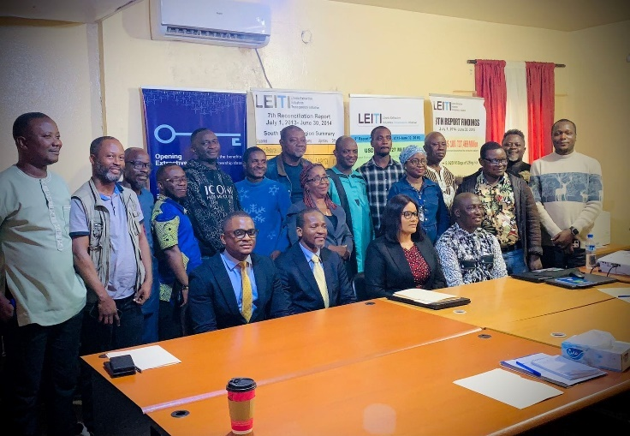
The workshop emphasized the need for continuous engagement and collaboration among stakeholders. Participants were encouraged to share their experiences, insights, and challenges in implementing BO Transparency. The discussions highlighted the importance of a coordinated approach to ensure that the true owners of companies operating in Liberia are identified and held accountable.
Madam Marilyn Logan of LPRA flanked by HoS Jeffrey N. Yates
Various stakeholders posed for the press after the daylong event

Workplan Development with Broader Constituency Outside of the MSG
Beginning May 5, 2024, the Liberia Extractive Industries Transparency Initiative (LEITI) Secretariat launched an inclusive, participatory process to gather input for Liberia’s 2024-2025 EITI workplan. Recognizing the importance of engaging stakeholders beyond the Multi-Stakeholder Group (MSG), the Secretariat initiated consultations with broader constituencies to ensure the workplan reflects a holistic, comprehensive approach to transparency, accountability, and governance in the extractive sector.

The first phase of this process focused on engaging civil society organizations (CSOs) outside of the MSG framework. On May 5, 2024, a one-day workshop brought together representatives from 15 civil society organizations. These organizations, although not directly part of the MSG, play a critical role in promoting transparency and accountability in natural resource governance. During the workshop, participants conducted a thorough review of the draft workplan and offered insightful contributions to strengthen the document. Key inputs included recommendations to increase budget allocations, strengthen sustainability measures, and integrate mechanisms to improve the dissemination of Liberia’s EITI Reports. Participants underscored the importance of leveraging an interagency approach to reporting and dissemination, emphasizing that collaboration among government agencies could enhance public awareness and understanding of the country’s extractive sector.

Following the civil society consultations, the Secretariat replicated this engagement with government and industry representatives on May 16, 2024. This session provided a platform for stakeholders within the government’s constituency, but outside of the MSG, to review, discuss, and contribute to the draft workplan. These consultations brought diverse perspectives, enriching the work plan with practical, actionable insights. Key discussions focused on securing sufficient budgetary support for LEITI’s activities and on exploring strategies to sustain transparency initiatives over the long term. Participants also highlighted the need for stronger collaboration between LEITI and other government institutions to implement the workplan’s objectives better.

At the opening of each working session, the Deputy Head of the LEITI Secretariat, Zaza Quaqua, encouraged participants to engage as free thinkers and active contributors, emphasizing that their input is essential for better and more transparent management of Liberia’s natural resources. Mr. Quaqua’s remarks set the tone for open and constructive dialogue, fostering an environment where participants felt empowered to share their ideas and concerns.

The Secretariat’s commitment to inclusivity and stakeholder engagement aligns with the core principles of the EITI Standard, which emphasize transparency, accountability, and collaboration. By involving stakeholders beyond the MSG, LEITI ensures the workplan addresses the needs and priorities of a broader constituency, fostering ownership and shared responsibility for its implementation.

Following the consultations with civil society, government, and industry stakeholders, the Secretariat compiled the various inputs into a consolidated draft workplan. This draft will be presented to the whole MSG for review, finalization, and subsequent approval. The MSG’s approval process will provide an additional layer of scrutiny, ensuring that the workplan meets the highest standards of transparency and accountability.


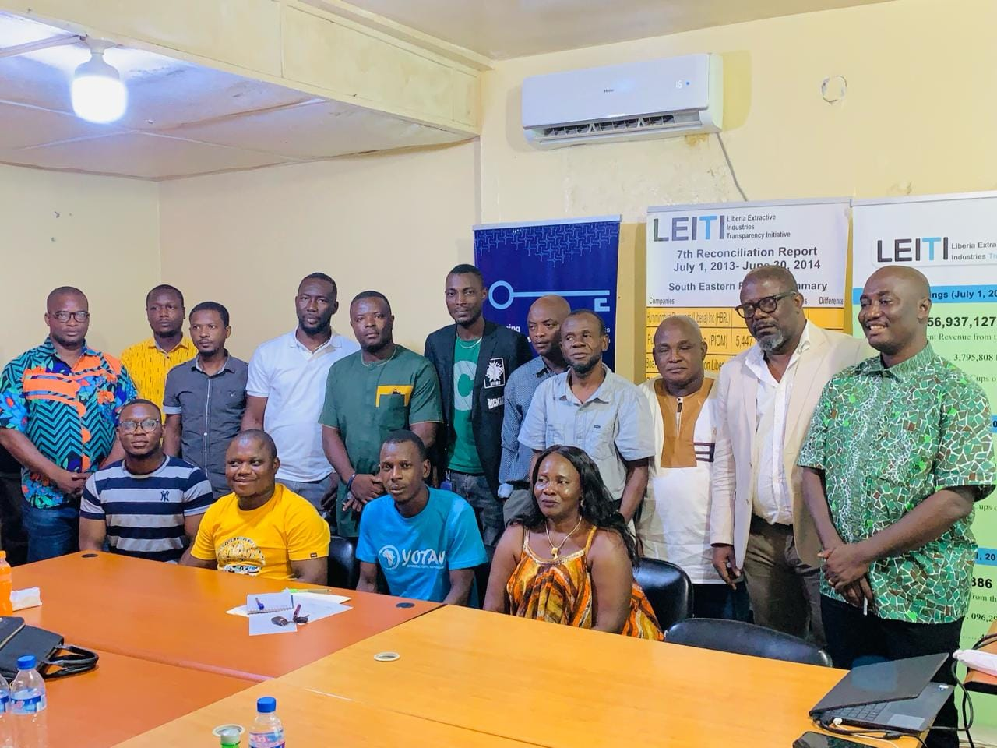
The development of Liberia’s 2024-2025 EITI workplan underscores LEITI’s commitment to fostering meaningful stakeholder engagement and promoting good governance in the extractive sector. By incorporating diverse perspectives and prioritizing collaboration, LEITI continues to uphold its mandate to ensure that the country’s natural resources are managed transparently and accountably for the benefit of all Liberians.
DHOS Zaza Y. Quaqua addressing one of the working sessions
CSOs outside of the MSG attending the working session

Details of Membership of the MSG during the Period
Membership—consistent with Section 6.1 of the LEITI Act of 2009, the MSG shall comprise at least fifteen (15) members drawn from three constituencies—the Government of Liberia, the Civil Society, and the Private Sector. The Act further requires seven representations from the GoL, including the Minister of Finance (now the Minister of Finance and Development Planning); the Minister of Lands, Mines, and Energy; the Managing Director of the Forestry Development Authority; the President/CEO of the National Oil Company of Liberia or its successor and two members each representing the Senate and House of Representatives. The Civil Society representatives include Publish What You Pay Liberia or its successor organization and a representative of a recognized association or union of workers in the extractive sectors as permanent members. At the same time, the Private Sector is required to have four representatives, one from each of the mining, forestry, agriculture, and oil sectors, as permanent members. A few of Liberia’s development partners are also on the MSG as observers.

The table below provides details of MSG membership during the period under
review.

Current MSG Membership
Civil Society Representatives
Mrs. Cecelia Danuweli | Publish What You Pay – Liberia
Mr. Winston W. Wreh | Liberia Labour Congress
Mr. Abraham B. Gappie | Mineral Civil Society Organizations of Liberia
Amb. George Kingsley | National Civil Society Council of Liberia
Private Sector Representatives
Cllr. Michael V. Suah | Mining Sector Representative
Mr. Elvis G. Morris | Agriculture Sector Representative
Mr. James M. Strother | Oil Sector Representative
Mrs. Eliza D. J Kronyanh | Forestry Sector Representative
Government Sector Representatives
Hon. Rudolph J. Merab Sr. | Forestry Development Authority
Hon. Augustine K. Ngafuan | Ministry of Finance and Development Planning
Hon. Wilmot J. M. Paye | Ministry of Mines and Energy
Hon. Rustolyn S. Dennis | National Oil Company of Liberia
Dr. Alexander J. Nuetah | Ministry of Agriculture
Cllr. N. Oswald Tweh | Ministry of Justice
Hon. James Dorbor Jallah | Liberia Revenue Authority
Hon. Marilyn T. Logan | Liberia Petroleum Regulatory Authority

ORIENTATION OF NEW GOVERNMENT’S CONSTITUENT MEMBERS
On March 28, 2025, the Liberia Extractive Industries Transparency Initiative (LEITI) Secretariat hosted a pivotal orientation meeting for members of the Multi-Stakeholder Group (MSG). The event was organized to provide newly appointed MSG members with critical insights into the LEITI Act, their roles and responsibilities, and an update on the local implementation process of the Extractive Industries Transparency Initiative (EITI). The orientation marked a significant milestone in ensuring that Liberia remains compliant with EITI standards as it prepares for validation in 2025.
The session was presided over by Cllr. T. Nagbalee Warner, an esteemed lawyer and the first Head of the LEITI Secretariat. In his address, Cllr. Warner emphasized the MSG’s role in fostering transparency, accountability, and good governance in Liberia’s extractive sector. The current Head of Secretariat, Mr. Jeffrey Nukata Yates, also graced the meeting and welcomed participants, providing an overview of the progress and challenges facing the LEITI.
In his opening remarks, Mr. Jeffrey Nukata Yates expressed gratitude to the new and returning MSG members for their commitment to advancing LEITI's objectives. He highlighted the importance of their role in driving the country’s compliance with EITI standards and maintaining Liberia’s reputation as a champion of transparency in the extractive industries.
Mr. Yates provided an update on Liberia’s EITI implementation, outlining key achievements and challenges. Among his achievements were improvements in data collection and reporting, enhanced public awareness of resource governance issues, and strengthened stakeholder collaboration. However, he also highlighted significant challenges, including limited funding, capacity gaps, and the need for stronger government support.
He called on MSG members to actively address these challenges and reaffirmed the Secretariat’s commitment to supporting their efforts. Mr. Yates further underscored the importance of the 2025 validation process, urging members to work collaboratively to ensure Liberia’s compliance with EITI standards.
The orientation meeting was convened in response to recent changes in the MSG's composition following new government appointments after the 2023 national elections. Its primary objectives were to:
- Familiarize new MSG members with the LEITI Act and the principles of the EITI.
- Clarify the roles and responsibilities of the MSG in promoting transparency and accountability in the extractive sector.
- Provide an update on Liberia’s EITI implementation, including progress, challenges, and opportunities.
- Strengthen the capacity of MSG members to contribute to the LEITI process effectively.
The orientation featured a series of presentations and discussions led by experienced facilitators. Key highlights included:
- Overview of the LEITI Act: Cllr. T. Nagbalee Warner provided an in-depth overview of the LEITI Act, emphasizing its significance as the legal framework for promoting transparency and accountability in Liberia’s extractive industries. He explained LEITI's mandate and the MSG's critical role in ensuring compliance with EITI standards.
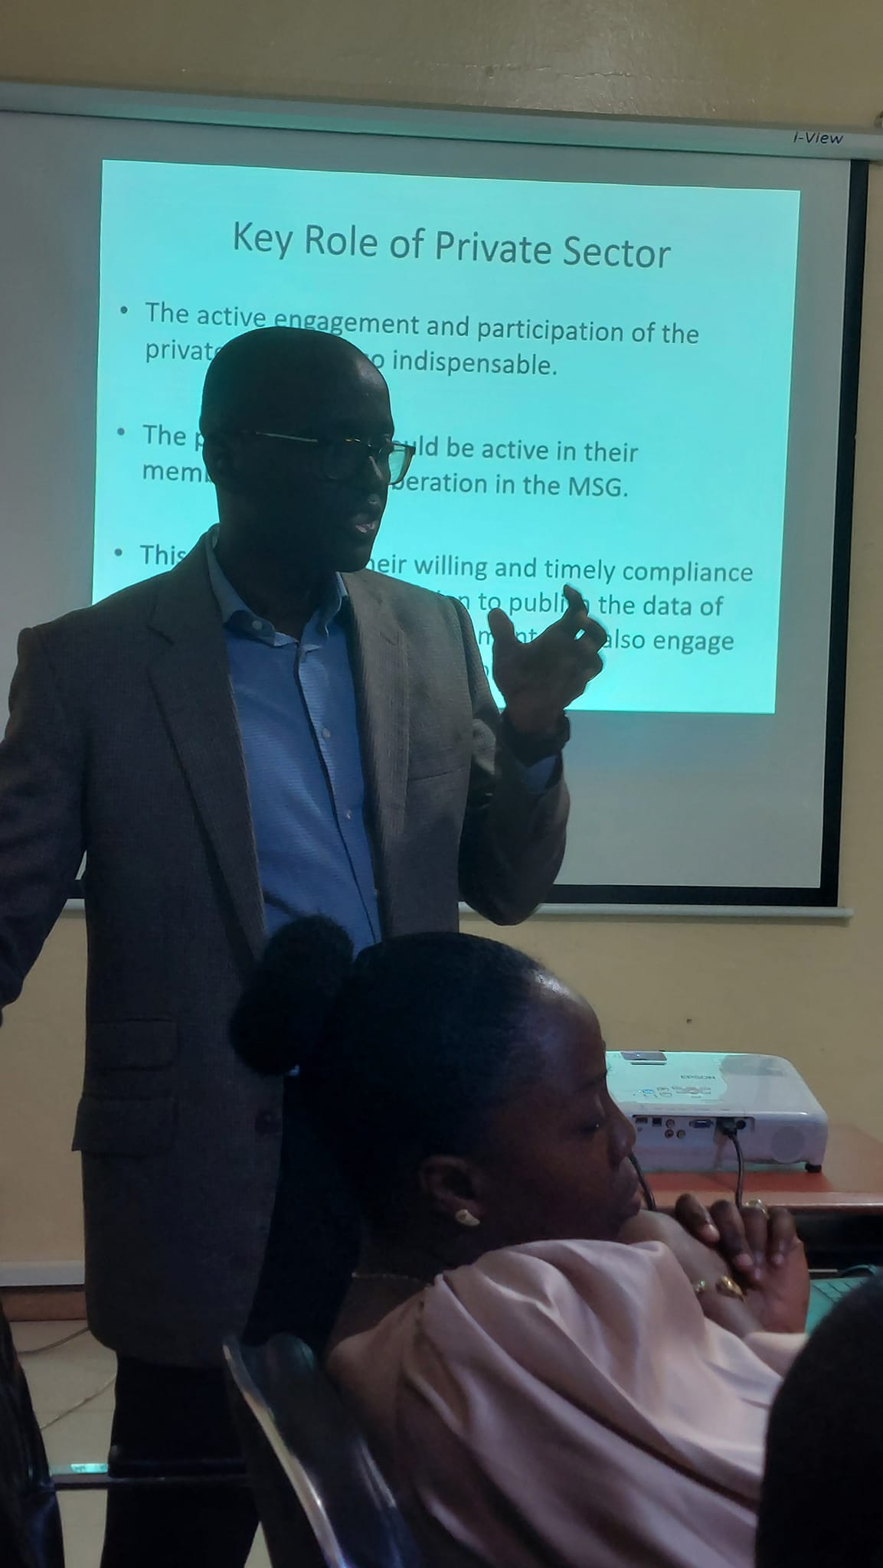
- Roles and Responsibilities of the MSG: Participants were briefed on the structure, composition, and functions of the MSG. The presentation underscored the importance of the tripartite partnership among government, civil society, and industry representatives in fostering inclusive decision-making and promoting good governance.
- Progress and Challenges in EITI Implementation: Mr. Jeffrey Nukata Yates provided a detailed update on Liberia’s EITI implementation. He highlighted key milestones, including the publication of recent EITI reports, improved stakeholder engagement, and ongoing capacity-building initiatives. However, he also outlined challenges, including resource constraints, data discrepancies, and the need for more effective stakeholder collaboration.
- Preparing for Validation in 2025: Participants discussed the importance of the upcoming validation process and its implications for Liberia’s standing in the global EITI community. The Secretariat emphasized timely and accurate reporting, effective stakeholder engagement, and continuous capacity building to ensure a successful validation.
The orientation meeting provided MSG members with a solid foundation for effectively contributing to Liberia’s EITI process. The event highlighted the critical role of the MSG in promoting transparency and accountability in the extractive sector and reinforced the Secretariat’s commitment to supporting their efforts.
Cllr. Nagbalee Warner, the first Head of the LEITI Secretariat, facilitated the meeting

Meetings—the MSG conducts its regular meetings quarterly. However, where urgency is required, emergency meetings are held. Additionally, matters requiring scrutiny are referred to specific committees, which decide on them and make recommendations to the body.

During these meetings, issues of concern are discussed and policy decisions are made while the MSG is also briefed by the Head of Secretariat on the status of planned activities and other progress at the Secretariat. Most decisions are reached by consensus, but where consensus cannot be obtained, the body would resort to voting. Observers can contribute to the discussions but are not eligible to vote.

The MSG in 2025 had regular and call meetings. The LEITI MSG, at the end of 2022, decided to transition from monthly meetings to quarterly meetings, with the option to hold emergency gatherings as needed. The rationale was to allow senior managers and Government officials to attend these quarterly meetings, given the long intervals. All decisions arrived at these sittings were derived through consensus building.

Approval by the MSG

_____________________________ Date: ______________________
Proxy - Chair Person / LEITI MSG

